Zycus Supplier Network (ZSN) Portal: Navigation Guide
Summary
The Zycus Supplier Network Portal (ZSN) allows suppliers to seamlessly engage with Seqwater via a convenient web portal. Suppliers can use ZSN to manage their company data, upload compliance documents and respond to requests for quotes and tenders. This guide provides guidance for suppliers completing core ZSN processes.

Contents
1. Registration Process 2
1.1. Existing Suppliers 2
1.1.1. Do you already have a Zycus Supplier Network (ZSN) Account to work with other customers? 2
1.1.2. Edit Profile 3
1.2. New Suppliers 3
1.2.1 Register as a Potential Supplier 3
1.2.2 Respond to Onboarding Request 4
2. ZSN Account Administration 5
2.1. Add or edit authorised supplier contact details 5
2.2. Forgot your password? 7
2.3. Update or add bank account details 7
2.4. Update or add Insurance Certificates 9
3. Notes 11
3.1. EFTSure Bank Detail Verification 11
3.2. Sourcing Activities 11
3.3. Clearing your browser cache 11
3.4. For Assistance 11

- Registration Process
All suppliers of goods and services to Seqwater are required to register on the Zycus Supplier Network (ZSN). This document provides guidance on how to navigate the Zycus Supplier Network (ZSN) as a supplier to Seqwater.
Please note: When accessing the Zycus Supplier Network (ZSN), the system will not automatically save your progress, so please remember to save regularly when completing tasks, including sourcing event responses.
  - Existing Suppliers
Seqwater has already uploaded data for its current suppliers to the Zycus Supplier Network (ZSN) Portal, so existing suppliers do not need to set up a new company profile. In early April 2026, an email was sent to authorised supplier contacts at the email address Seqwater had on record, inviting them to update existing Zycus Supplier Network (ZSN) Accounts or to create a new Zycus Supplier Network (ZSN) Account. Only authorised Seqwater contacts are permitted to complete the registration steps for existing suppliers as described below.
If you did not receive an invitation to register or are unsure of who in your organisation is an authorised Seqwater contact, please contact CommercialServices@seqwater.com.au for assistance.
Please Note: Email must match the email address the notification was sent to.
    - Do you already have a Zycus Supplier Network (ZSN) Account to work with other customers?
If yes, please follow the steps below:
- If your Zycus Supplier Network (ZSN) Account uses the email address registered with Seqwater, log in through the “Existing User?” Login with Password or OTP panel to link it to your new Seqwater supplier profile.
- If you use a different email for your Zycus Supplier Network (ZSN) account, create a new account with the email known to Seqwater. Once this is set up, you can add your other Account to your Seqwater supplier profile.
Please Note: Zycus portal registrations are unique for each customer you work with. If your business has registered with other customers using the ZSN portal, you need to register with Seqwater separately. When you are registered and log in, you can then toggle between your customers to engage with them.
If not, this is how to register and activate your Account.
- If you are a newly registered supplier, or an existing supplier who has not yet activated your Account on our Zycus Supplier Network (ZSN) Portal, you will be required to complete the following steps in Section 1.2., before gaining access to your supplier account with Seqwater.
- If you have received an email notification from our Commercial Services team with the subject “Welcome to the Zycus Supplier Network - Action required”. In the email there will be an Seqwater link to open the Zycus Supplier Network (ZSN) Portal.

    - Edit Profile
To update your Zycus Supplier Network (ZSN) Supplier Profile Information after the initial profile completion:
- Seqwater.
- Account.
- My Companies.
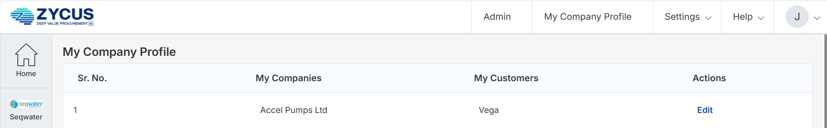
- Edit.

Please Note: For security purposes, all changes to supplier details are reviewed and approved by Seqwater (this can take several days). Refer to “My Requests” in the Zycus Supplier Network (ZSN) Portal for status update.
Please note: If you need help creating your ZSN account, please contact commercialservices@seqwater.com.au
  - New Suppliers
Any business or contractor not currently transacting with Seqwater, can register their interest for future opportunities by accessing their Zycus Supplier Network (ZSN) Seqwater profile and creating a Potential Supplier profile. The Supplier Information page on the Seqwater website provides additional information and guidance.
    - Register as a Potential Supplier
To register as a Potential Supplier on the Zycus Supplier Network (ZSN) Seqwater Profile:
- Go to https://dewdrops.zycus.com/zsp/guest/genericRegister/SEQ322.
- On the “New User? Register” panel on the right, enter the following information:
  - Enter your email address
  - Enter a Password the conforms to the requirements
  - Confirm the Password
  - Answer the arithmetic question
- Tick the box to accept the Zycus Terms and Conditions.
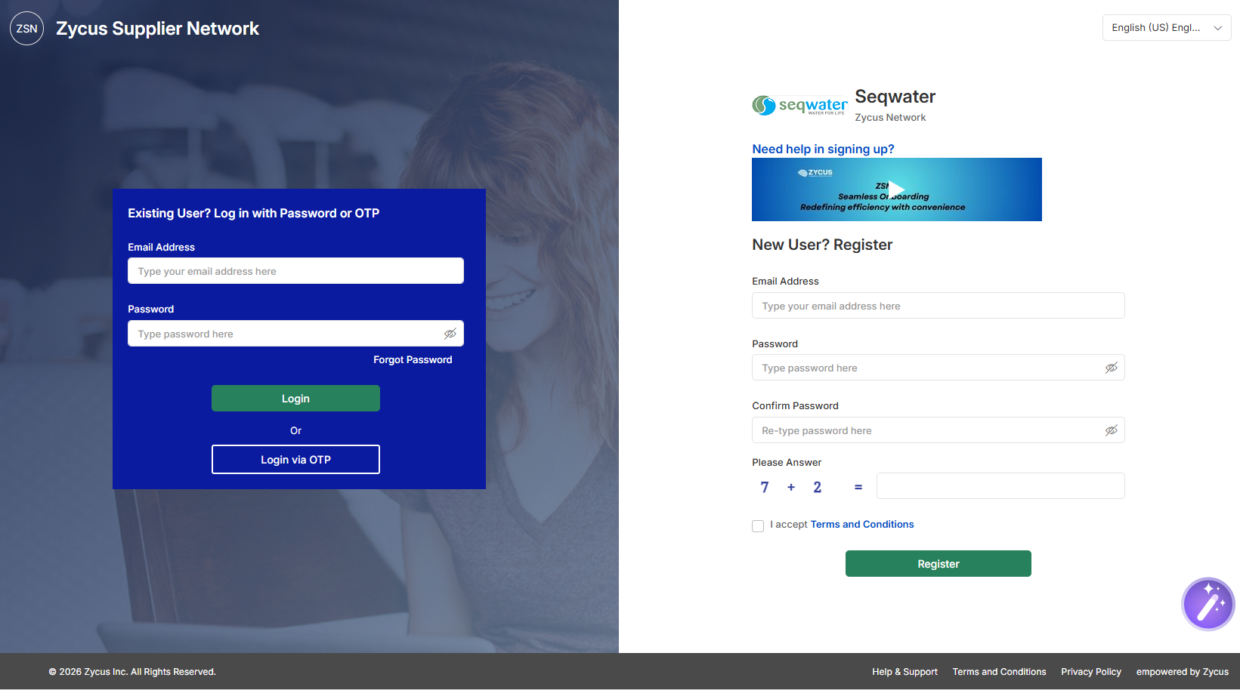
- Click on the Register button.
- A one-time password (OTP) will be sent in an email to the address used for registration. Retrieve the OTP from the email and enter the OTP in the Enter OTP field', then click on Verify OTP.
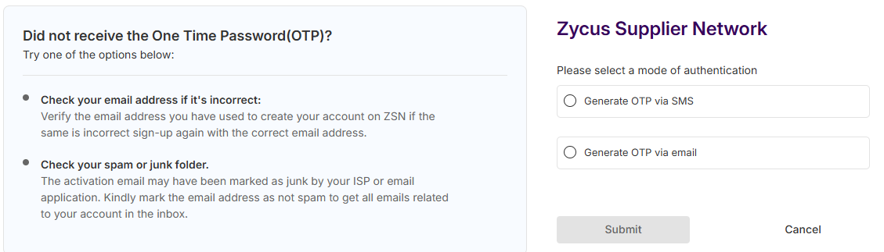
- Complete the profile information.
Please note: You’ll be able to add bank details, insurance certificates and other information once you receive an onboarding request email from Seqwater.
    - Respond to Onboarding Request
If selected to provide a product or service to Seqwater, a registered Potential Supplier will receive a notification requesting additional information such as bank details, insurances or other information.
Click the link in the email notification to login.
Please note: If you need help creating your ZSN account, please contact commercialservices@seqwater.com.au

- ZSN Account Administration
  - Add or edit authorised supplier contact details
- Login to Zycus Supplier Network (ZSN) (https://dewdrops.zycus.com/zsp/guest/genericRegister/SEQ322) using your existing account credentials.
- Click on the Seqwater Profile icon on the left of screen.
- Click on ACCOUNT, then select MY COMPANIES.
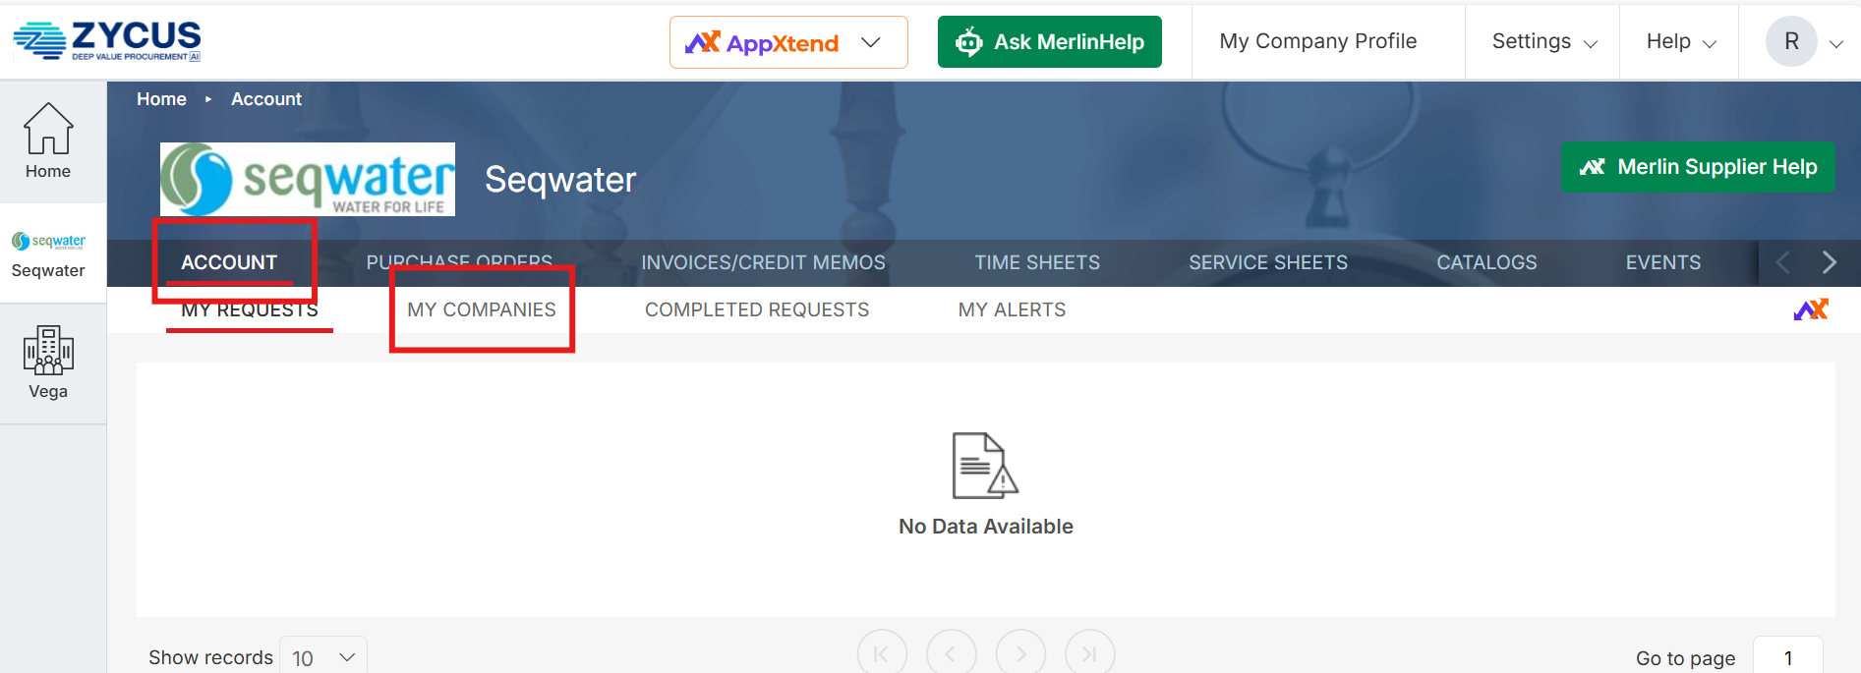
- Click on the Edit button.
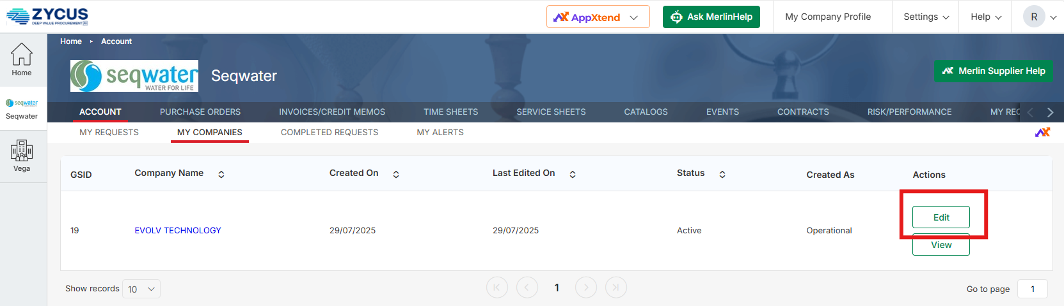
- On the left menu, select Address.
- Ensure that the Account Group is marked as HQ, OA, RT.
- Scroll down to Showing Contact Details for All Locations section.
- Click on the Add New button to add a person/email address authorised to operate on the Zycus Supplier Network (ZSN) Account.
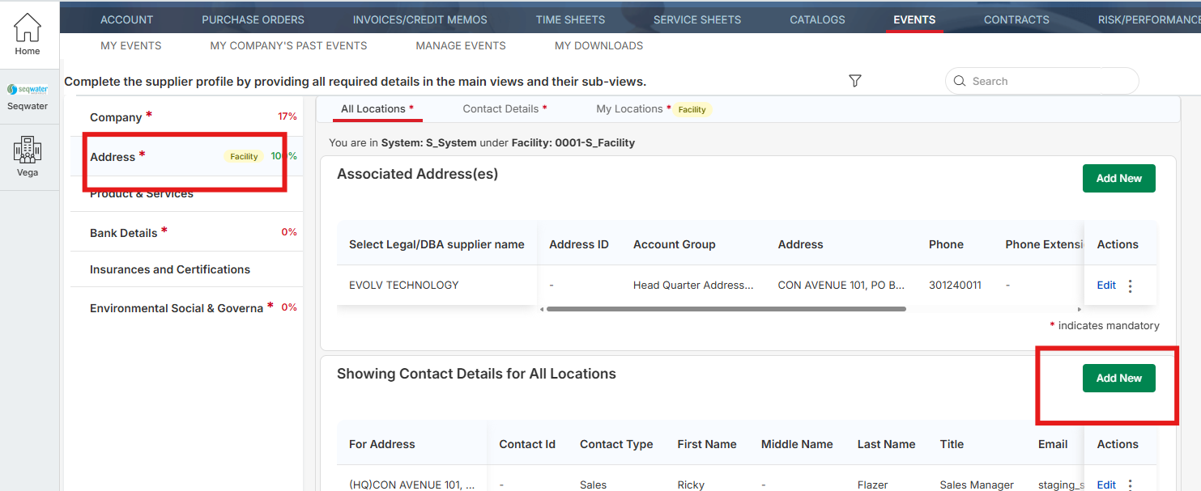
- Enter data in all the mandatory fields.
- Ensure that the Contact Type fields are completed with the appropriate points of contact, as this enables Seqwater to identify which contacts are responsible for specific transaction types:
• AR = remit-to address
• PO = receive POs
• Pricing = purchasing / RFQs
• Sales = procurement (ie sourcing/contracts)
• Others = any other roles
• After Hours = after hours service
- Set the Seqwater Supplier Portal Access field to Yes.
- Click to select which Zycus Supplier Network (ZSN) Modules to be assigned to the new contact.
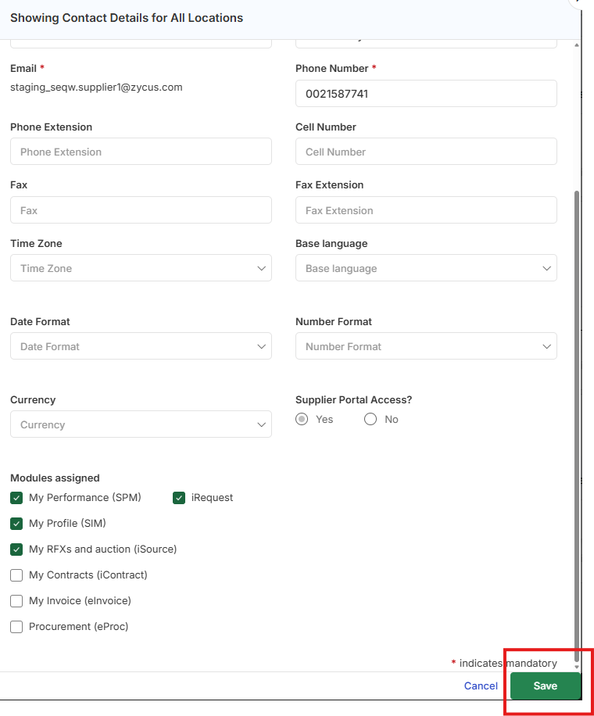
- Click Save.

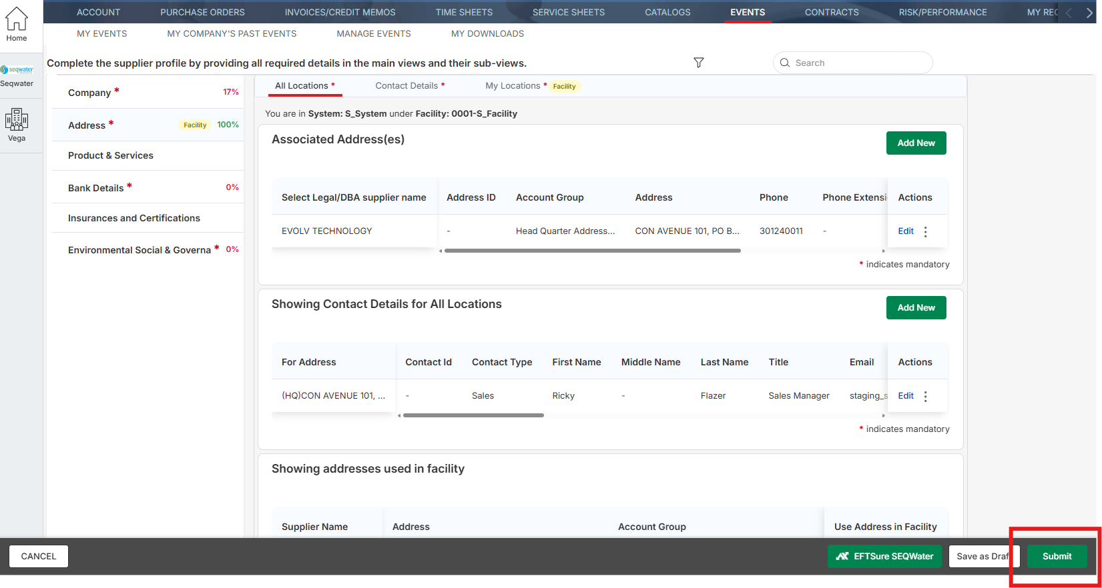
- Click Submit.
- After submission, the “My Requests” tab will display your request status as “Submitted”.
Please note: Assigning access to My Profile (SIM) allows the new contract to add additional contacts, as well as modify the modules assigned to themselves and all other contacts.
  - Forgot your password?
If you cannot remember your password, you can reset it from the Zycus Supplier Network (ZSN) login page using the email address registered to your account.
- Go to the ZSN login page and select Forgot Password.
- Enter the email address linked to your ZSN account.
- Follow the prompts to request a password reset or one-time password (OTP), if prompted.
- Check your email inbox for the password reset message or OTP and follow the instructions provided.
- Create a new password that meets the system requirements, then confirm it.
- Return to the login page and sign in using your registered email address and new password.
Please Note: If you do not receive the reset email, check your junk or spam folder first. If you still cannot access your account, contact commercialservices@seqwater.com.au for assistance.
  - Update or add bank account details
As part of Seqwater’s security requirements, all suppliers are required to update their banking information directly via the Zycus Supplier Network (ZSN). We are unable to update bank details on your behalf.
Please note you will need to log in using your registered email address and password to access the Zycus Supplier Network (ZSN).
To add/edit your bank details information:
- Login to ZSN (https://dewdrops.zycus.com/zsp/guest/genericRegister/SEQ322) using your existing email address and password.
- Click on the Seqwater Profile icon on the left of the screen.
- Click on ACCOUNT, then select MY COMPANIES.
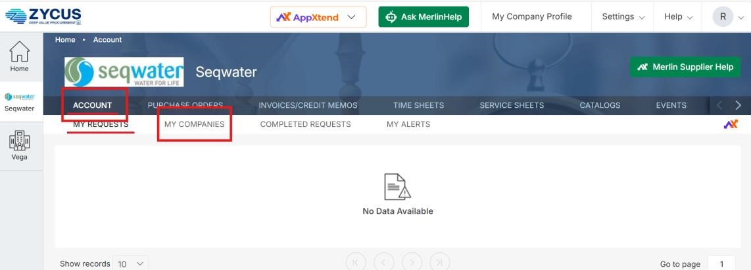
- Click on the Edit button.
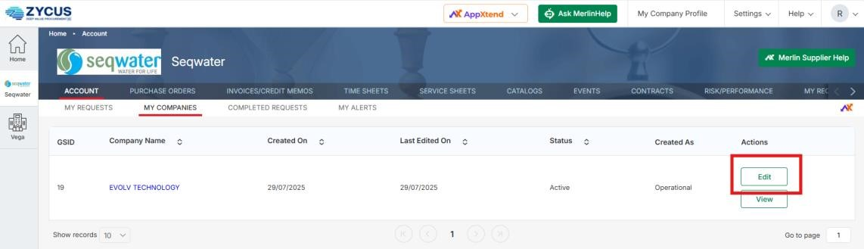
- On the left menu, select Bank Details.
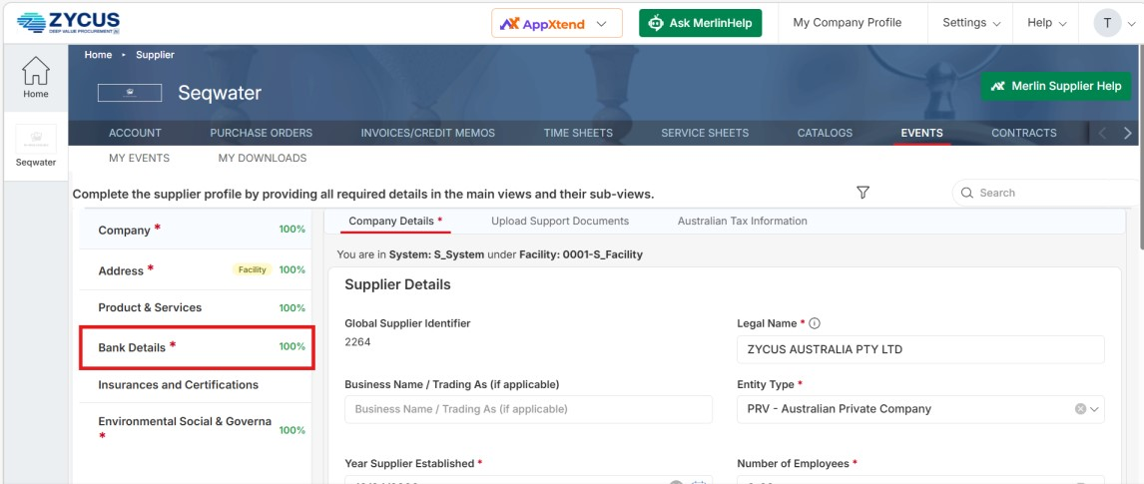
- Click on the Edit button to edit the existing bank details.
- Ensure that the Account Group is marked as HQ, OA, RT to be able to amend Bank Details.
- Update all applicable fields, ensuring data is entered in all the mandatory fields.
Note: The Bank Code Type field should be $BSB for Australian bank accounts and $BIC for International bank accounts.
Note: For Australian bank accounts, ensure the BSB number includes a hyphen between the first three digits and last three digits e.g. XXX-XXX 8. Upload your supporting documents.
- Click Save.
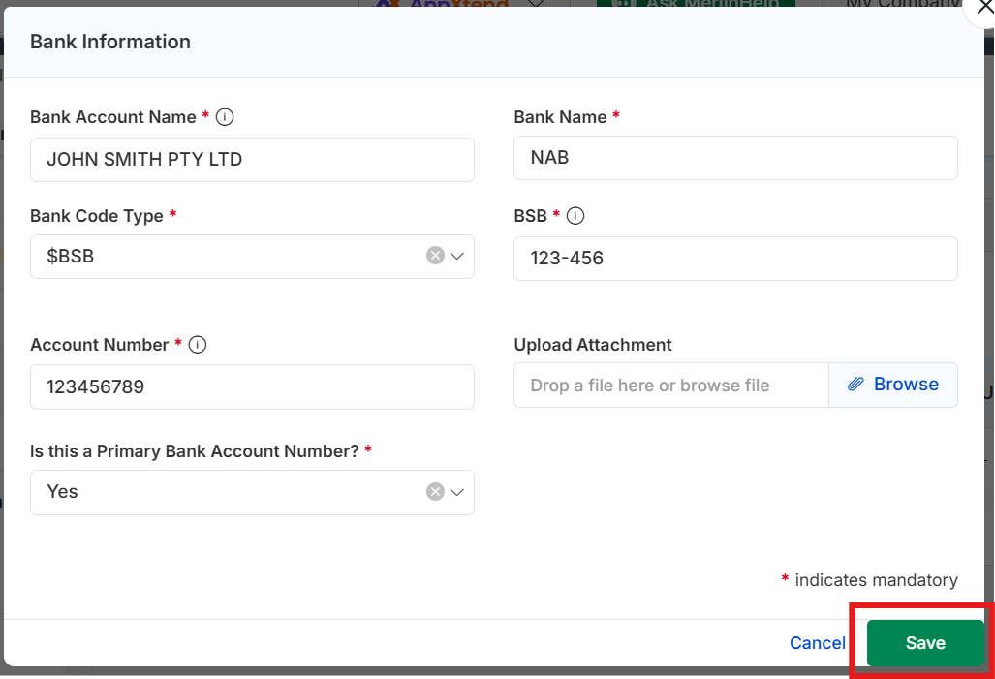
- Click Submit.
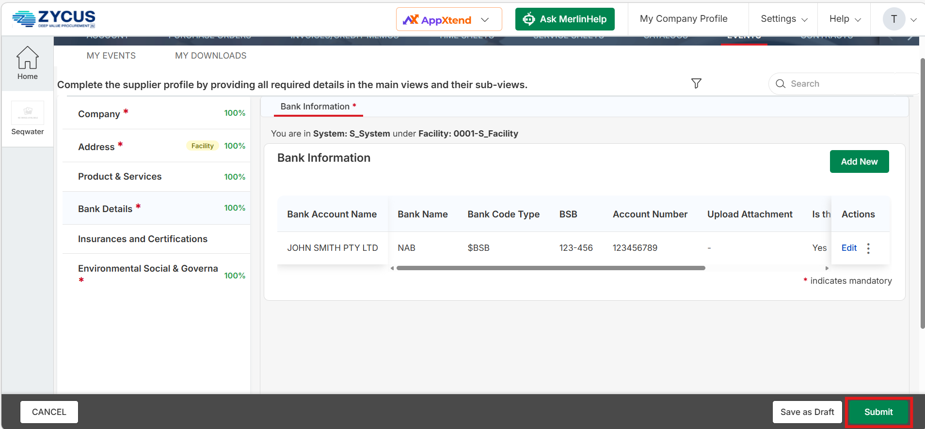
Please Note: For security purposes, all changes to supplier details are reviewed and approved by Seqwater.
  - Update or add Insurance Certificates
As part of Seqwater’s requirements, all suppliers are required to update their Insurance Certificate information directly via the Zycus Supplier Network (ZSN).
Please note you will need to log in using your registered email address and password to access the Zycus Supplier Network (ZSN).
To add/edit your bank details information:
- Login to ZSN (https://dewdrops.zycus.com/zsp/guest/genericRegister/SEQ322) using your existing email address and password.
- Click on the Seqwater Profile icon on the left of the screen.
- Click on ACCOUNT, then select MY COMPANIES.
- Click on the Edit button.
- On the left menu, select Insurances and Certifications.
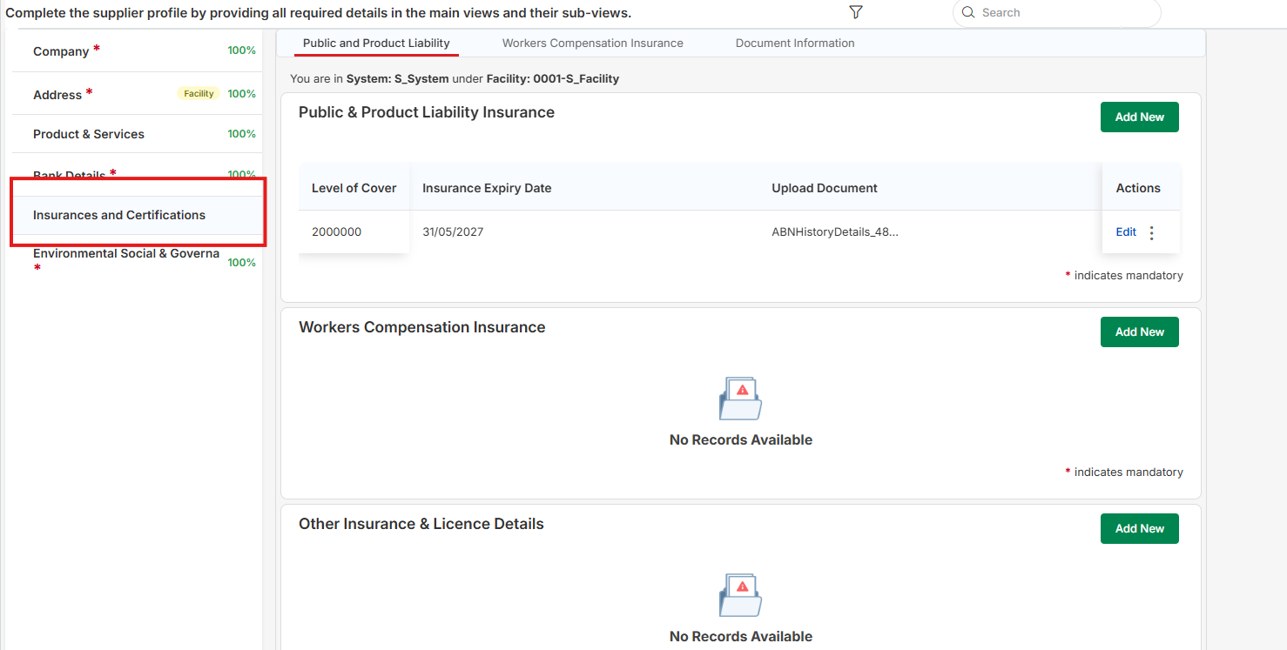
- Click on Add New for each section and upload insurances and certifications.
- Alternatively, click on Edit to update an existing record.
- Click Save.
- Click Submit.
Please note: When accessing the Zycus Supplier Network (ZSN), the system will not automatically save your progress, so please remember to save regularly when completing tasks, including sourcing event responses.
- Notes
  - EFTSure Bank Detail Verification
Suppliers are required to enter details such as Name, ABN, address, contact name and number, bank account details, and attach insurance certificates and proof of bank account and address. EFTSure is a separate tool used for bank account verification to protect both Seqwater and our suppliers from fraud attempts. You may be contacted by a member of the EFTSure team to verify your account details over the phone. Please refer to the FAQs for more information.
  - Sourcing Activities
Seqwater uses Zycus to manage all market sourcing activities. Invitations to participate in sourcing activities are issued through ZSN, allowing suppliers to respond directly to the sourcing event and receive notifications about the outcome.
  - Clearing your browser cache
If you are having difficulty logging in to the Zycus Supplier Network (ZSN), clearing your browser cache may help
resolve the issue. Your browser stores temporary website files to help pages load faster, but these files can
sometimes prevent updated pages from loading correctly or cause login issues.
Before clearing your cache, please save any work in progress and close any other ZSN browser tabs. Clearing cookies or site data may also sign you out of other websites.
1. Open your browser settings.
2. Go to the privacy, security or browsing data section.
3. Select the option to clear browsing data.
4. Choose cached images and files. If login issues continue, you may also need to select cookies and other site data.
5. Select a suitable time range, such as All time, then clear the data.
6. Close and reopen your browser, then try logging in again.
  - For Assistance
If you require assistance with the Zycus Supplier Network (ZSN) Portal, or have any questions or concerns relating to working with Seqwater, please contact commercialservices@seqwater.com.au.

