I-TMP-STD-005 Functional Description Part B
Document number: TEM-00222
This document is the property of Seqwater. It must not be copied or reproduced in any way whatsoever without the authority of Seqwater. This document is uncontrolled when printed. An electronic database manages and stores the controlled version.
Ver No. | Description | Document Owner |  | Document Approver
Ver No. | Description | Position | Approval | Position | Approval | Approval Date
5 | Amended Version | Lead Engineer - Operational Technology | Refer to supporting Info in Rex | Team Leader Process & Analysis | Refer to supporting Info in Rex | 24/01/2024
This Engineering Standard was endorsed by an RPEQ on behalf of Seqwater.
This page shall be deleted by the contractor.

Approval Process
Where noted in this Template that Seqwater approval, attention or input shall or should be sought, the Seqwater Team Leader DTI Service Delivery - PAT (or their delegate) shall be responsible for reviewing or generating the technical response. A request for approval, attention or input shall made via the Seqwater Project Representative (for external parties) or via Seqwater’s Engineering mailbox (engineering@seqwater.com.au) (for internal parties).

Changes from Previous Version
This Template will be regularly reviewed and updated, including the consideration of requested alterations, in accordance with Seqwater Procedure X-PRO-STD-004 Development and Review of Asset Standards.
Table 1 Changes from previous version
Section Number | Change
Cover page | Cover page for the template and actual FD B document separated
All | Format changed to be more site specific than project specific

Verification
Compliance with this document may be verified by internal audit.

Further Information
Consult Seqwater’s Engineering mailbox Engineering@seqwater.com.au for following points prior to beginning work on FD B for any sites
- Document type: Plantwide FD B or site specific
- Document number
- REX ID
Delete the first two Template cover page of this document for the actual FD B document.
For further information please contact the owner of this document.
This page shall be deleted by the contractor.

Insert name of site/area/project

Functional Description Part B
Date: DD/MM/YYYY

Doc. No.: Request from Seqwater as per X-PRO-STD-019
REX ID: XX/XXXX Request from Seqwater as per X-PRO-STD-019

Template Document number: TEM-00222
Revision History
Date | Rev | Description of Comments or Changes | Author | Checked By | Approved By
dd/mm/year | 0 | ‘Add project details If updated as part of project’ | Full name - Position Company | Full name - Position Company | Full name – RPEQ # Position Company
The extent of changes to this document is highlight in green.
Review History
Date | Rev | Reviewer | Position | Comments Received | Comments Incorporated

Contents
1. Purpose 7
2. Audience 7
3. Abbreviations 8
4. References & Associated Documents 9
5. Holds List 10
6. Scope 11
7. Overall Plant Control Philosophy 11
8. Plant Control System 13
8.1. PLC 13
8.2. Application Program Architecture 13
8.3. Program Block Usage 14
8.3.1. Seqwater Standard PLC Blocks 14
8.3.2. Site Specific Software PLC Blocks 14
8.4. Sequential Start-Up of the Entire Plant 14
8.5. Normal Sequential Shutdown of the entire plant 16
8.6. Abnormal Shutdown Plant of the entire plant 16
8.7. Control Reliability 16
8.7.1. Control System Architecture Reliability 16
8.8. Common Alarms 17
9. SCADA Configuration Details 17
9.1. SCADA System 17
9.2. Software Objects Library 17
9.3. Site Specific SCADA Objects 18
9.4. Graphic display list 18
9.5. Trending 18
9.6. SCADA Hierarchy Structure and Menu Structure 18
9.6.1. Displays/Screen Graphics 19
9.6.2. Indication Signals 19
9.7. SCADA Database Configuration Details 19
9.8. Reporting 19
9.8.1. HL pump Reporting (e.g., only) 19
9.9. User roles and Privileges Levels 20
10. Communication Details 20
10.1. Networks 20
10.2. Communication Hardware 20
10.3. IP Address Schema 20
10.4. Seqwater WAN Connection 20
10.5. Network Diagnostic 20
11. Name of Process Group e.g. Raw Water Pump Station 21
11.1. Process Overview 21
11.2. Control System Hierarchy (Can be an Appendices) 21
11.3. Calculations 21
11.4. Equipment and Instrumentation 22
11.5. Equipment or Instrument Scaling 23
11.6. Control 23
11.7. Control Loops 24
11.7.1. Settled Water Channel Level Primary Controller (E.G. Only) 24
11.8. Hardware Interlocks and Permissive 25
11.9. Sequence Control 26
11.10. Alarms 27
11.11. Events & Indications 27
11.12. Setpoints and Parameters 28
12. PLC Signal Processing Requirements 28
Appendix A 29

- Purpose
How to use this standard/template:
This template is used to produce a Functional Description Part B. Further details on the development of Functional Descriptions are contained in B-SPE-STD-005 Functional Description Documentation.
All table & figure captions, cross references, table of contents etc. are automatically updated by pressing ‘Ctrl + A’ or right clicking over any greyed-out captions and selecting ‘update field’.
All items in grey highlighting are for reference and guidance. These should be changed or deleted as required.
For facility code of the asset refer to X-PRO-STD-002 Engineering Drawing Number Procedure, Appendix A.
The objective of this Functional Description Part B is to describe the site / area / project functionality. It explains and details the equipment hierarchy, redundancy, pre-start, start-up, operation, shutdown and isolation conditions, constraints, interlock & fault conditions, abnormal operation, safety features and ancillary information. It is intended to provide all the necessary details essential for developing application software and configuration of control system for the plant.
In addition to this Functional Description Part B is Part A. The inter-relationship between Part A and B are described in B-SPE-STD-005 Functional Description Documentation.
This Functional Description is a ‘dynamic document’ and should be updated with changes to the asset design and operational control intent.
This Functional Description is to be read in conjunction with the site / area / project P&IDs, PFDs and FD Part A as specified in Section 4.
This document does not include operational procedures. This is to be defined within Operations Manuals for site / area / project.
The Functional Description is a document that should be created by the designer. It is intended to provide all the necessary detail to describe the processes, the control, and all information necessary to develop and implement the control system for the plant. It is not an Operations and Maintenance Manual.
- Audience
This document has been developed specifically for, but not limited to, the following:
- Control System Engineers
- Control System Programmers
- Process Engineers

- Abbreviations
Abbreviation | Description
CCP | Critical Control Points
FB | Function Blocks
FC | Functions
FD | Functional Description
HACCP | Hazard Analysis and Critical Control Points
I/O | Input / Output
MAOP | Maximum Allowance Operating Pressure
MCC | Motor Control Centre
NAS | Network attached storage
OHS | Occupational, Health and Safety
P&ID | Piping and Instrumentation Diagram
PFD | Process Flow Diagram
PLC | Programmable Logic Controller
RIO | Remote Input Output
SCADA | Supervisory Control and Data Acquisition
SFC | Sequential function chart
UC Number | Supervisory Control Number
UPS | Uninterruptable Power Supply
WTP | Water Treatment Plant

- References & Associated Documents
Table 4.1 Site Specific Referenced Documents
Description | Status | Location | Rev
Functional Description Part A | [Active or draft] | [REX ID]
Cause & Effect Matrix | [Active or draft] | [REX ID]
O&M manual | [Active or draft] | [REX ID]
Vendor Process description & Vendor Process drawings | [Active or draft] | [REX ID]
Alarm Register | [Active or draft] | [REX ID]
SCADA Setpoint Register | [Active or draft] | [REX ID]
Control Network Drawings | [Active or draft] | [REX ID]
I/O List | [Active or draft] | [REX ID]
IP Register | [Active or draft] | [REX ID]
Table 4.2 P&IDs
Drawing Number | Description | Rev
Add P&ID related to projects
Table 4.3 Generic Referenced Documents
Description | Status | Location | Rev
SPE-00361 Control System Design and Construction (I-SPE-STD-013) | Active | REX/Waternet
PLN-00388 Monitoring and Control System Alarm Strategy (I-SPE-STD-006) | Active | REX/Waternet
SPE-00356 High Priority Alarms and Interlocks management (I-SPE-STD-005) | Active | REX/Waternet
SPE-00360 Control Systems Testing (I-SPE- STD-11) | Active | REX/Waternet
SPE-00359 Control System Tag Naming (I-SPE-STD-010) | Active | REX/Waternet
SPE-00358 I-SPE-STD-009 Control Systems Architecture | Active | REX/Waternet
SPE-00349 Functional Description Documentation (B-SPE-STD-005) | Active | REX/Waternet
PRO-02329 Process Control Systems Information Maintenance Procedure (X-PRO-STD-019) | Active | REX/Waternet
Reference 1 | [Active  or draft] | [REX ID]
- Holds List
The following HOLDs are noted throughout this document. These are highlighted yellow and noted as TBC for ease of finding.
Table 5 List of HOLDs
HOLD No. | Section | Description of HOLD | Status
 |  |  | Open/Closed

Part B
- Scope
The scope of this document relates to the ‘site name’ plant control system programming functionality. It mainly gives following details:
- Process overview in brief (details in the plant FD A ‘FD A Document number’).
- Details for PLC configuring and developing the application program as per process requirements including interlocking or sequence step actions and conditions.
- Details for SCADA configuration and graphics design as per operator interface requirements.
- Associated risks and plant safety.
This section shall also list’ the boundaries of the plant control covered.
- Overall Plant Control Philosophy
This section shall cover the process overview briefly which can be used for programming the control system. Some points below can be covered briefly keeping the description as process related.
- Start up
- Shut down
- Form of logic implemented (regulatory / sequence / interlock)
- Group or plant sequences with details as below (add table below where applicable):
Table 7.1 Group or plant sequence table (examples in grey below)
Top Level Controller | TLI_9UCxx0001 | Main Supervisory Controller
Subordinate Controllers | TLI_9UCxx0002 | Production Supervisory Controller
Subordinate Controllers | TLI_1UCxx0001 | Raw Water Supervisory Controller
Subordinate Controllers | TLI_2UCxx0001 | Membrane 1 Supervisory Controller

- Interfaces to other plants/ systems
- Interlocks for plant supervisory controllers such as crash interlock, shutdown interlocks, service permissive interlocks and device monitoring interlock (Add table if applicable, refer to I-SPE-STD-013 for further details)
- Control Modes (reference to I-SPE-STD-013 (and revision number if different to the current version) and only site-specific details in this document). Generic block diagrams as seen in the e.g., below can also be added:
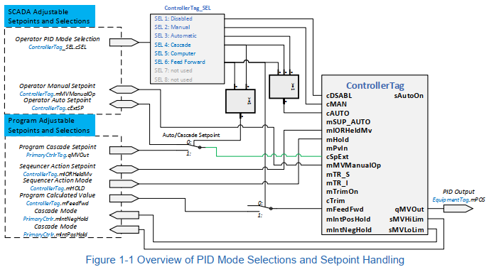 Schematic is an example only to be deleted.
Figure 7-1 Overview of PID Mode Selections and Setpoint Handling Example

- Plant Control System
This section gives the overview of the control systems and software being used for plant.
The plant is controlled by PLCs as detailed in the following sections.
  - PLC
Table 8.1 PLC being used for control of site/equipment
Equipment Tag | Equipment Description | Equipment Type | Location
  - Application Program Architecture
Describe the controller hierarchy in application program (preferably in block diagram) giving references to respective Process group section. Wherever possible the controller’s names as per tag naming philosophy also to be added.
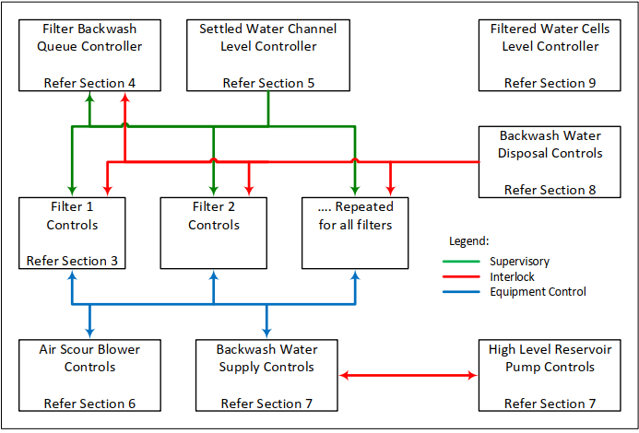 Schematic is an example only, to be deleted.
Figure 8-2 Controller Hierarchy Example
Refer to FD A for the overall process hierarchical table, representing a model of the physical assets under control.
Further details of group process control are detailed in the individual process group sections.
  - Program Block Usage
    - Seqwater Standard PLC Blocks
Table 8.3.1 Standard PLC Blocks
Name | Description | Datasheet No. | Rev
    - Site Specific Software PLC Blocks
Site specific Functions (FC) and Function Blocks (FBs) or User Defined Data Types developed for the plant application program are as below.
Table 8.3.2 Site Specific Software PLC Blocks
Name | Description | Datasheet No. | REX ID | Rev

  - Sequential Start-Up of the Entire Plant
This section briefly describes the process start up. Refer to FD A document for details.
Preference is to have Process start-up to be represented in a graphical flowchart format by analysing the data from FD A.
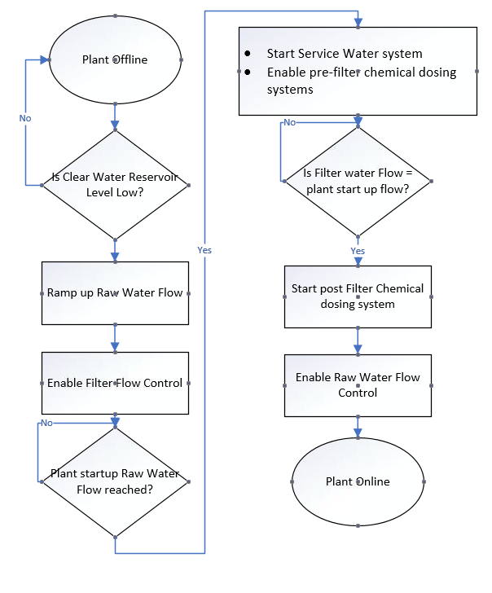 Schematic is an example only, to be deleted.
Figure 8-4 Sequential Start-Up Diagram Example
Representation of process in flow chart does not necessarily means that it has to be a sequential logic written in sequential functional chart (SFC) or other sequencing PLC languages.
Option of brief description (as per example below) shall be acceptable, but not preferred:
If the plant permissive conditions are met, the plant will start as below (see links to individual start-up sequences):
- Wait for the Clear Water Reservoir level to drop below the (operator adjustable) start-up set point.
- Delay for 30 seconds.
- Ramp up Raw Water flow: begin ramp up of summated RW flow at operator adjustable rate.
- Enable filter flow control.
- Wait until Raw Water flow reaches plant start-up flow.
- Start Service Water system and enable pre-filter chemical dosing systems.
- Wait until Filtered Water flow reaches plant start-up flow.
- Start post-filter chemical dosing systems.
- Wait until Raw Water flow reaches final set point.
- Enable Raw Water flow control.
- Set plant status to ‘Online’.
  - Normal Sequential Shutdown of the entire plant
Refer to FD A document for details.
Preference is to have a flow chart representation to describe sequence steps and transition condition for normal shutdown. Otherwise, a brief description of the shutdown sequence is expected.
  - Abnormal Shutdown Plant of the entire plant
An emergency shutdown is initiated by operator input or failure of the on-site power generator or any site major fault.
Flow Chart representation is desired also some points to consider in this section as below:
- Abnormal shut down conditions e.g., Power failure, communication failure, process group unavailability etc.
- How the overall plant control responds to the above conditions.
- Auto restart of the plant shall be disabled in case of Abnormal shutdown.
- Avoid duplication by referring to other sections of the process group in the documents.
  - Control Reliability
    - Control System Architecture Reliability
This section shall describe how the control system design addresses the failure modes which can affect the reliability of the control systems. Some guidewords for failure modes are as below:
- Power supply - Redundant Power Supply, UPS backup, PLC Rack and RIO Rack separate Power Supply;
- Instrumentation - Use of redundant instrument/channels for critical parameters or use of instrumentation with higher reliability;
- Architecture - Class I, II or III depending on the reliability requirements;
- Hardware failure - Fail Safe wiring and logic;
- Common cause failures - Distribution of equipment / IOs;
- Communication failures - Fail safe actions; or
- Any Specific conditions that will ensure the plant control brings the process to a safe state, in case of any of the above failures.
  - Common Alarms
Refer to Alarm list I-LST-XXX-XXX for details on plant common alarms.
Some common examples of alarms to be considered as common alarms are as below:
- Overall plant safety alarms / HACCP
- PLC Diagnostic alarms
- Communication failure alarms
- Electrical instrumentation alarms
- Fire Safety Alarms
- Safety Showers
It is not expected to describe the third-party equipment alarms (lights and beacon) which are not connected to the control system in the FD Part B.
- SCADA Configuration Details
  - SCADA System
‘Product name of SCADA system’ system provides an operator interface to the plant control system. Refer to System architecture drawing ‘Number and REX ID ‘for further details.
SCADA System design and configuration shall follow the requirements of I-SPE-STD-013 Control Systems Design and Construction.
Site specific SCADA system details are as below:
Table 9.1 Site Specific SCADA system details
Equipment Tag | Equipment Type | Equipment Name | Location
 | SCADA Server | As per tag naming philosophy
 | SCADA Client
 | SCADA Thin Clients
 | Historian
Refer to ‘Architecture drawing number’ for further details.
  - Software Objects Library
All devices and graphics on SCADA use the ‘Seqwater standard library’ or ‘use the current site name’ specific object library.
In case of site-specific library details needs to be filled in in the below table:
Table 9.2 Software Objects Library
Object Name | Description | Datasheet No. | REX ID | Rev
  - Site Specific SCADA Objects
Site specific SCADA objects or SCADA objects developed for the plant application are as below.
Table 9.3 Site Specific Software PLC Blocks
Name | Description | Datasheet No. | REX ID | Rev
  - Graphic display list
The following table below gives the list of graphics for plant control of ‘Site Name’
Mark the new graphics in green, and the deleted graphics in Blue.
Table 9.4 Graphics Display List
Graphics Name | Description
 | Plant Process Overview
 | Network Overview
 | PLC and Communication diagnostic
 | Power System Overview
 | Water Quality
 | Treated Water Reservoir Overview
  - Trending
Trending, trend sampling, events and logging periods have been configured as per the Trends section in I-SPE-STD-013 Control System Design and Construction.
  - SCADA Hierarchy Structure and Menu Structure
Plant wide hierarchy of SCADA displays and menu structure has been developed as per I- SPE-STD-013 Control System Design and Construction standard. In case of site-specific library being used, the details shall be referred in datasheet listed in Table 9.3 Site Specific Software PLC Blocks.
Some key points to cover are as below:
- Layout of popup menus and faceplates
- Button functions
- Nested menu layers
    - Displays/Screen Graphics
Insert all details/redline mark-ups /print screens of displays and screens for the programmer to build new screen or modify existing screens. This shall stay in the ‘For Construction’ FD Part B.
In the ‘As constructed ‘ FD Part B these details shall be deleted and referred to Section 4.3
    - Indication Signals
Refer to standard I-SPE-STD-013 for further details.
Plant specific details/graphics of default indication signals on SCADA such as below shall be mentioned here:
- Alarm, Warning and Signal Events
- Operational Mode
- Simulation and Bypass Events
Along with the default indications some Device Block icons have additional information such as process variable readouts, device status indicators and graphical animations. These shall be referred to the respective datasheets.
  - SCADA Database Configuration Details
For further information on SCADA database refer section SCADA Software, subsection SCADA Database in I-SPE-STD-013 Control Systems Design and Construction standard.
This section is to describe how the SCADA Database is configured. Include information such as data capture frequency, rapid trend data retention periods, archiving frequency, manual/automatic backup configuration, hardware setup (Network attached storage (NAS) drive, dedicated historian server, etc.).
  - Reporting
For standard report configuration requirements refer to the Reporting section in I-SPE-STD-013 Control Systems Design and Construction standard.
Table 9.8 Site Name Generated Reports
Report Number | Title | Type
1 | Water Treatment Plant Data | Free Format
2 | Pump Status Report | Microsoft Excel
4 | Hourly Report | Free Format
5 | Daily Report | Free Format
6 | HL Pumps Running | Alarm and Event
7 | Alarm Disabled Report | Point Attribute
The site-specific reports developed are as per following sections.
    - HL pump Reporting (e.g., only)
Configuration details of any site-specific reports to be developed need to be detailed as sub sections in FD part B revision ‘For Construction’.
In the FD part B revision ‘As Constructed ‘ only the report name is to be listed in Table 9.8 and all configuration details removed from this section.
  - User roles and Privileges Levels
Refer to the user roles and privileges in I-SPE-STD-013 and I-SPE-STD-005 for more details.
Additionally, this section describes if any site-specific levels and specific privileges are required. (e.g., for interlocks bypass, alarm acknowledge, etc.).
- Communication Details
  - Networks
The site communication network is designed as per I-SPE-STD-009 Control Systems Architecture.
This section provides details of communication network as mentioned in the following sections:
- SCADA LAN, PLC LAN and RIO Lan.
- PLC to PLC communication (intra site / external Seqwater site).
- Radio communication.
- Digital communication details (Ethernet TCP/IP, Fieldbus, profibus, profinet etc.).
- Interfaces to 3rd party equipment.
- Interfaces to external parties such as Unity water etc.
  - Communication Hardware
Details of communication cabinet for the plant are listed in the table below:
Table 10.2 Communication Hardware
Cabinet Equipment No | Description | Location
For other hardware details refer to the Site-specific Architecture Drawing REX ID.
  - IP Address Schema
Refer to the Site-specific IP Register / Schema ‘Document Number’ and ‘REX ID’.
  - Seqwater WAN Connection
The Remote access requirements for the process group are as below:
  - Network Diagnostic
Diagnostic details are configured as per ‘Communication and Diagnostic’ section in I-SPE-STD-013. Additionally, this section specifies the site-specific network diagnostic signals.
- Name of Process Group e.g. Raw Water Pump Station
  - Process Overview
Provide a brief overview of how this Process Group operation/functional unit is controlled in form of a block diagram. It shall be helpful to add in the ‘UC’ numbers on each of these controllers seen in Figure 11-1 Control System Hierarchy Example. Avoid repeat of copying word details from FD A.
  - Control System Hierarchy (Can be an Appendices)
This section shall display key objects that make up the control system hierarchy. A flow chart representation as below shall be a desired option (with supervisory block names as per PLC logic included).

Figure 11-1 Control System Hierarchy Example
  - Calculations
Details on any calculations used for process control such as dosing calculations etc. and its purpose shall be described in this section.
Tie up calcs in FD A and Vendor Datasheet here with some explanation to link both, wherever possible tag number to be provided in the equation.
Equation X: Dosing Rate Calculation Example
sVREQ = $\frac{mFPROC × mDRREQ × 0.36}{cSG × cCONC}$

Where $sVREQ$= Calculated dose rate in L/hr
$mDRREQ=$ Flow Paced SP in mg/L from SCADA
$mFPROC$= 100-FIT-001 flow rate in L/s
$cCONC$= Solution concentration SP in % w/w from SCADA
$cSG$= Specific Gravity SP from SCADA

The desired flowrate in flowpaced dosing mode is to be calculated using the Seqwater library block “Dose_Calc” (see datasheet I-DSH-STD-062).

Wherever possible tag number to be provided in the equation.
  - Equipment and Instrumentation
List the equipment and instrumentation that is under control from this Process Group. Items that are under control from subordinate Plant Units should be listed in that section, not as part of this section.
Table 11.4.1 Process Unit Equipment List
Equipment Identifier | Description
TMG-3PMD001  (800-PMP-005)* | Alum Dosing Pump
TWB-M-1FAN001 | Raw Water Pump Station Vent Fan 1
TWB-V-1XV400 | Raw Water Pump 4 Delivery Valve
*Note: For new instruments the equipment identifier needs to match with new tagging philosophy, in case of existing equipment enter new as well as old equipment identifier if not updated on P&ID.
Table 11.4.2 Process Unit Instrument List
Instrument Identifier | Description1
TMG-3FIT001 | Alum Dosing Flowmeter
TWB-V-1XV100 | Raw Water Pump 1 Delivery Valve
Refer to the IO List for details on range and units
  - Equipment or Instrument Scaling
This section shall refer to the site standard IO List (not a project specific document).
Only any special scaling requirements for any equipment if required.
Table 11.5 Equipment with special scaling requirements
Equipment Identifier | Raw Min | Raw Max | Engineering Unit | Engg Min | Engg Max
  - Control
The control system application software for this process group is configured in the ‘PLC name’.
For management of ‘Name of Process Group’ system the ‘name of supervisory control ‘ is the highest level of the supervisory control. The control system hierarchy between the process is as seen in figure XXX below: Process Units is also listed here.
List the equipment that is under control from this Process Group preferably in form of block diagram, example below:
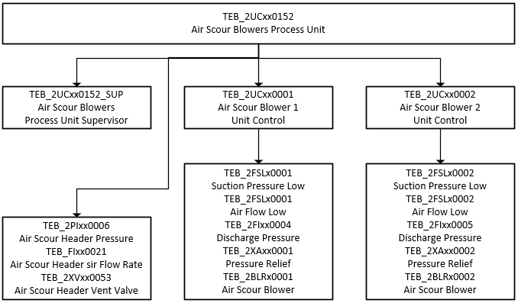
Figure 11-2 Control System Hierarchy for ‘Name of Process group’
Or alternatively it can be shown in a table format as below:
Table 11.6 Control System Hierarchy for ‘Name of Process Group’
Process Group | PLC Name | Process Unit Supervisory Controller | Process Equipment
Raw Water Pump Station  1UC-XXX |  | 1UC-001 Raw Water Pump Set 1 | Raw Water Pump 1
Raw Water Pump Station  1UC-XXX |  | 1UC-001 Raw Water Pump Set 1 | Raw Water Pump 1 Delivery Valve
Raw Water Pump Station  1UC-XXX |  | 1UC-002 Raw Water Pump Set 2 | Raw Water Pump 2
Raw Water Pump Station  1UC-XXX |  | 1UC-002 Raw Water Pump Set 2 | Raw Water Pump 2 Delivery Valve
Raw Water Pump Station  1UC-XXX |  | 1UC-002 Raw Water Pump Set 2 | Raw Water Pump 2 Cooling Water Valve
Raw Water Pump Station  1UC-XXX |  | 1UC-002 Raw Water Pump Set 2 | Raw Water Vent Fan 1
Raw Water Pump Station  1UC-XXX |  | 1UC-003 Raw Water Pump Set 3 | Raw Water Pump 3
Raw Water Pump Station  1UC-XXX |  | 1UC-003 Raw Water Pump Set 3 | Raw Water Pump 3 Delivery Valve
Raw Water Pump Station  1UC-XXX |  | 1UC-004 Raw Water Pump Set 4 | Raw Water Pump 4
Raw Water Pump Station  1UC-XXX |  | 1UC-004 Raw Water Pump Set 4 | Raw Water Pump 4 Delivery Valve
Raw Water Pump Station  1UC-XXX |  | 1UC-004 Raw Water Pump Set 4 | Raw Water Pump 4 Cooling Water Valve
Raw Water Pump Station  1UC-XXX |  | 1UC-004 Raw Water Pump Set 4 | Raw Water Vent Fan 2
Raw Water Pump Station  1UC-XXX |  | 1UC-005 Raw Water Pump Set 5 | Raw Water Pump 5
Raw Water Pump Station  1UC-XXX |  | 1UC-005 Raw Water Pump Set 5 | Raw Water Pump 5 Delivery Valve
Describe any control system functionality that is not captured in other parts of this section.
  - Control Loops
Specify how many control loops are existing in the process i.e. how many analog loops and digital control loops. For analog control loops, further specify whether it is PID based, or the output of the analog loops is based on calculations.
Table 11.7 Process Group ‘Name’ Control Loops
Tag | Type | Short Description/ Function
TEB_2LICx0021 | PID | Settled water channel level Primary controller
TWB_FICx0001 | PID | Raw Water Pump Flow Slave Controller
TWB_2LICx0800 | PID | Dosed Filtered Water Wet Well Level Controller
TMG_3FICx0001 | PID | Alum pump Flow control
    - Settled Water Channel Level Primary Controller (E.G. Only)
The Settled Water Channel Level Controller (TEB_2LICx0021) uses the measured levels of the water flowing from the sedimentation basins into the filters to determine a common Filter Velocity Setpoint to balance the load across all the online filters. The PID serves as a cascade master controller providing the common setpoint value for the secondary PID flow control loops on the individual filters.
The output of the Settled Water Channel Level Controller (TEB_2LICx0021.sOUT) is the common Filter Velocity Setpoint in meters per hour.
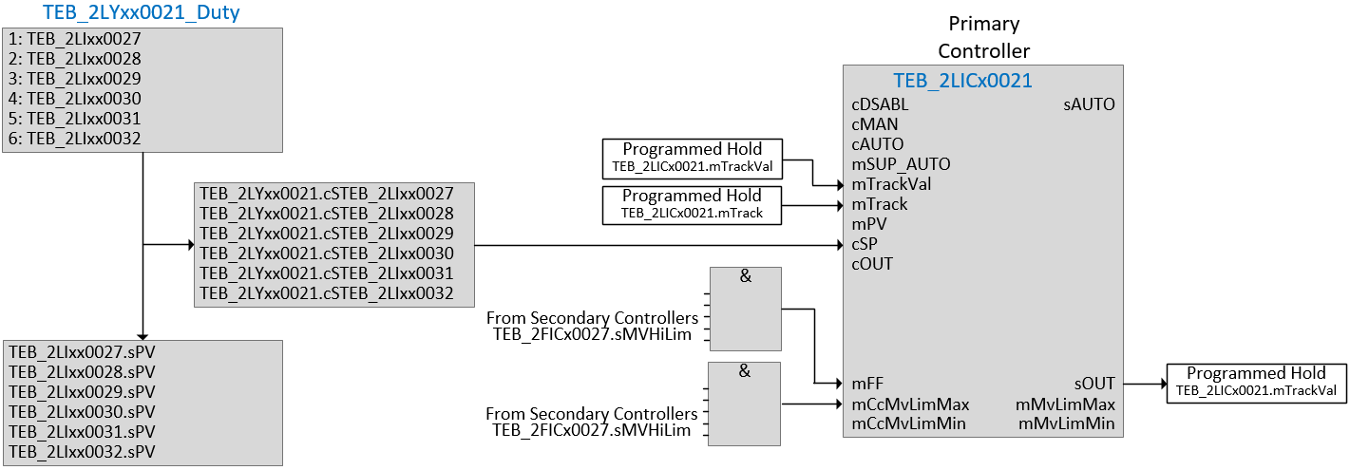
Figure 11-3 Block diagram representation of logic Example
Add subsection for additional details such as mode selection, setpoint selection etc.
  - Hardware Interlocks and Permissive
For trip interlock and safety interlocks conditions, please refer to site ‘I-REGG-AAA-NNN Cause & Effect Matrix.
The below table details hardware interlocks and permissive for units and devices under the control of this process group. Only hardware interlocks are in all modes all other interlocks and permissive are in Remote Auto mode only.
Repeat the below table as many times as necessary to capture the relevant Process Units and Devices
Table 11.8 Interlocks and Permissive
Identifier | Tag Number – Could be a Device or Process Unit supervisor
Description
Hardware Interlocks | Description (FD A reference section)
Process Permissive | Description (FD A reference section) | Delay
Tag Number, include logic for combining tags if required.  E.g. [LIT0801] < Auto-Stop level Set Point  AND [LIT0802] < Auto-Stop level Set Point | Click here to enter text. | Click here to enter text.
Start Permissives | Description (FD A reference where applicable) | Delay
P1 | e.g. Blower thermal overload fault, inlet valve closed | None
P2 | inlet valve closed | None
Duty/Standby/Assist | Details on any duty arrangements
Operating Modes | List any details on the modes of operation that exist. Refer to I-SPE-STD-013 for list of Equipment Modes and Control Modes.  e.g. Process critical equipment in disable mode; Maintenance function for specified equipment; Maximum time allowed for forcing for process critical equipment
Group Control Shutdown | Description (FD A reference where applicable) | Delay
Note: combine different causes for a trip under one number
  - Sequence Control
This section describes sequence control for running of equipment in ‘Process Unit Name’.
The preferential method is to show it in sequence chart as in Figure 7 below.
While describing the sequence following key points needs to be identified:
- Use tag identifiers to describe equipment and reference setpoints.
- Describe normal operation and abnormal operation during the sequence controls.
- The logic needs to identify step being ‘Complete’, ‘Executed’ or ‘Stopped’.
- It shall also show the parallel branching of the sequence path.
- Ability to monitor sequence crash stop.
Note: Representation of control in sequence chart does not imply that the SFC or Sequencer is to be used for developing the logic. The guidelines in I-SPE-STD-013 shall be followed for any sequential logic to be developed and needs Principal’s approval.
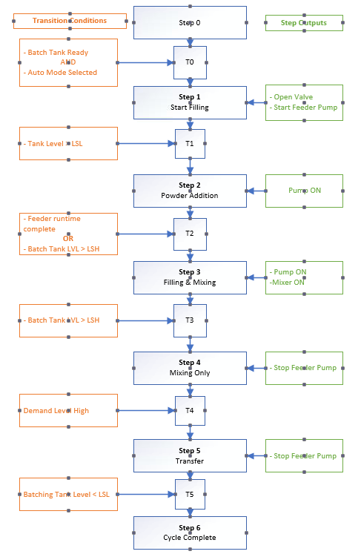Schematic is an example only.
Figure 11-4 Sequence Control
  - Alarms
Refer to Alarms and section in Control System Diagnostics in I-SPE-STD -013 Control Systems Design and Construction Standard for further information on configuration of alarms.
Detail alarm list can be found in I-LST-XXX-00X ‘Site Name’ Alarm Register.
  - Events & Indications
Refer to Events section in I-SPE-STD-013 Control Systems Design and Construction standard for further information on events and indications.
Add any project relevant information about events and indications here.
  - Setpoints and Parameters
Detail setpoints and parameters used for controlling this process group here. This is not an alarm list. Alarms are listed separately. Include Process Setpoints that can be adjusted by the operator from SCADA and PLC parameters.
Table 11.12 Setpoint and Parameter Table
Tag | Parameter Description | Unit | Min | Max | Default | SCADA Privilege level *
 | Raw Water Flow Setpoint | L/S | 0 | 278 | 200 | Operator
 | Raw Water Pump No-Flow Delay | secs | 0 | 999 | 10 | Manager
*Note SCADA Adjustable field should indicate authority level for change. A blank field indicates a PLC parameter that cannot be adjusted from the SCADA screen.
- PLC Signal Processing Requirements
Some points to consider for this section are and can be added:
- XXXX msec is the maximum Scan time of CPUXXX
- XXXX is the memory of the CPU XXX
- Maximum time between PLC-PLC Communication
- SOE (Sequence of event recording requirements
- External Barriers / Isolators installed for I/Os
- Use of external power source (DO or 4 wire transmitters)
- Special calibration requirements (gas detectors, analyzers)
- Digital inputs inversion requirements (ideally it needs to be wired in FS state) if not logic needs to take care of it.
- Safety loops present?
- Any Hazardous area installations

Appendix A
Intentionally left blank for project use

