I-TMP-STD-001
Functional Description Part A Template
Document number: TEM-00221
This document is the property of Seqwater. It must not be copied or reproduced in any way whatsoever without the authority of Seqwater. This document is uncontrolled when printed. An electronic database manages and stores the controlled version.
Ver No. | Description | Document Owner |  | Document Approver
Ver No. | Description | Position | Approval | Position | Approval | Approval Date
4 | Amended Version | Lead Engineer - Automation and Process Control | Refer to supporting Info in REX | Team Leader Process & Analysis | Refer to supporting Info in REX | 07/02/2025
This template was endorsed by an RPEQ on behalf of Seqwater.

This page shall be deleted before issue of the Functional Description Part A document.

Version History
Rev | Date | Description | Author | SME | Owner | Approver
0 | 2015 | Original Issue
1 | 6/12/2017 | Amended Version
2 | 18/12/18 | Amended Version
3 | 08/02/2022 | Amended Version
4 | 07/02/2025 | Amended Version
(Refer Controlled Document in REX for Author, SME, Owner and Approver details)

Approval Process
Where noted in this Template that Seqwater approval, attention or input shall or should be sought, the Seqwater Team Leader DTI Service Delivery -–Process & Analysis Team (or their delegate) shall be responsible for reviewing or generating the technical response. A request for approval, attention or input shall made via the Seqwater Project Representative (for external parties) or via Seqwater’s Engineering mailbox (engineering@seqwater.com.au) (for internal parties).
Verification
Compliance with this document may be verified by internal audit.

Further Information
Consult the Seqwater Project Representative (for external parties) or Seqwater’s Engineering mailbox(engineering@seqwater.com.au) for the following information prior to beginning work on FD A for any sites:
- Scope of document (Entire Plant, section of plant)
- Document number
- REX /ID
Delete the first three Template cover pages of this document before issue of the Functional Description Part A document.
For further information please contact the owner of this document.

[Site /Area]

Functional Description Part A

Date: [XX/XX/XXXX]

Document number: [Request from Seqwater as per X-PRO-STD-019]

REX ID: [Request from Seqwater as per X-PRO-STD-019]

This document is the property of Seqwater. It must not be copied or reproduced in any way whatsoever without the authority of Seqwater. This document is uncontrolled when printed. An electronic database manages and stores the controlled version.

Revision History
Date | Rev | Description of Comments or Changes | Author | Checked By | Approved By
dd/mm/year | 0 | “Add project details if updated as part of project” | Full name - Position Company | Full name - Position Company | Full name – RPEQ # Position Company
The extent of changes made to this document in the latest revision are highlighted in green. (Refer to X-PRO-STD-019).

Review History
Date | Rev | Reviewer | Position | Comments Received | Comments Incorporated

Contents
1. Purpose 8
2. Scope 8
3. Site / Area Overview (e.g. WTP/Pipeline) 9
3.1. Overall Process Description 9
3.2. Overall Start Up Sequence 9
3.3. Overall Shut Down Sequence 9
4. Insert Name of Process Group 10
4.1. Process Group Description 10
4.2. Process Group Performance Requirements 10
4.2.1. Water Quality Envelope 11
4.2.2. Process Constraints 11
4.3. Process Availability and Reliability Requirements 11
4.4. Equipment & Instrumentation Details 11
4.5. Process Operational Control Narrative 12
4.5.1. Calculations 12
4.5.2. Start Up 12
4.5.3. Shut Down 13
4.6. Abnormal Operation 13
4.7. Process Critical Alarms 13
4.8. Faults & Interlocks 13
4.9. OHS, Equipment and Process Safety Features 14
4.10. Ancillaries Information 14
5. Site/Area Process Hierarchy 15
6. Definitions & Abbreviations 16
7. References and Related Materials 17
8. Holds 18
Appendix A 19
9. Filtration Process Group 19
9.1. Process Group Description 19
9.2. Process Group Performance Requirements 19
9.2.1. Water Quality Envelope 19
9.2.2. Process Constraints 20
9.3. Process Availability and Reliability Requirements 20
9.4. Equipment & Instrumentation Details 20
9.5. Filtration Process Operational Control Narrative 20
9.5.1. Control Principals 22
9.5.2. States 23
9.5.3. Procedures 24
9.6. Backwash Control Narrative 26
9.6.1. Filter Drain Down 26
9.6.2. Air Scouring 28
9.6.3. Filter High Velocity Backwash 28
9.6.4. Filter Ripening 28
9.6.5. Filter Queuing 29
9.6.6. Backwash Sequence 30
9.7. Abnormal Operation 30
9.8. Process Critical Alarms 31
9.9. Faults & Interlocks 31
9.10. OHS, Equipment and Process Safety Features 32
9.11. Ancillaries Information 32

- Purpose
This document is part of a suite of Seqwater Engineering Standards, Specifications and Templates which are in alignment with the Seqwater Quality Management System. Their purpose is to provide a consistent approach to the development, modification, and management of Seqwater infrastructure that is fit for purpose, economic over the life of the asset, and meets Seqwater’s Work Health and Safety obligations.
How to use this template:
This template is used to produce a Functional Description Part A. Further details on the development of Functional Descriptions are contained in B-SPE-STD-005 Functional Description Documentation.
All table & figure captions, cross references, table of contents etc. are automatically updated by pressing ‘Ctrl + A’ then ‘F9’ or right clicking over any greyed-out captions and selecting ‘update field’.
All items in grey highlighting are for reference and guidance. These should be changed or deleted as required.
For facility code of the asset refer to the Asset Location Standard D25/38190.
The objective of this Functional Description Part A is to describe how site / area is to be controlled from a process perspective. It summarises the process envelope, normal and abnormal operation and defines key barriers and mitigations to maintain the process in safe operation bounds. In addition, the process hierarchy defined in Part A is crucial to the structure of the control system. The focus of Part A is high-level process control detail through narrative descriptions.
This Functional Description Part A is accompanied by a separate but related document, Functional Description Part B. Part B translates the high-level detail of Part A into low-level specifications to be used for implementation of the control system. The inter-relationship between Part A and B is further described in B-SPE-STD-005 Functional Description Documentation.
This Functional Description is a ‘dynamic document’ and should be updated with changes to the asset design and operational control intent. Refer to X-PRO-STD-019 Process Control Systems Information Maintenance for a procedure of how to update this document.
This Functional Description is to be read in conjunction with the site / area P&IDs and PFDs as specified in Section 4.
This Functional Description does not include operational procedures. These are defined within Operations Manuals for site / area.
- Scope
This Template applies to all Seqwater employees, contractors, suppliers and consultants working for, or on behalf of, Seqwater unless otherwise stated. Deviation from the requirements in this Template requires written agreement from Seqwater as per the deviation process detailed in X-PRO-STD-008 Asset Standards Management and Application.
Seqwater undertakes regular updates of its Engineering Standards. Before utilising this Template, the complete list of Seqwater Engineering Standards should be reviewed to ensure currency and applicability of standards to be applied to the works.
Advice must be sought from the Seqwater Document Owner, via the Engineering Mailbox, to clarify any ambiguities in relation to this Procedure.
This document has been developed specifically for, but not limited to, the following:
- Process Engineers;
- Control System Engineers;
- Instrumentation and Controls Engineers; and
- Operations Superintendents.
- Site / Area Overview (e.g. WTP/Pipeline)
Complete this section if creating a new FD(A) for a site / area. If the design is only for a specific process group and no FD(A) for the site / area already exists, place this section on HOLD and add the process group design(s) into the appropriate section(s) of this template.
- Overall Process Description
Provide a high-level overview description of the site/area from a process perspective. Provide relevant information of the site / area such as physical location, history (if applicable), function, overall purpose and process objectives of the area, interactions with other sites / areas and the environment, the arrangement of the system within the Bulk Water Supply Network (if applicable), etc. Insert block flow diagram of area here to assist the reader, if required.
A site / area is composed of a number of discrete process groups which interact to achieve the site/area’s process objectives. A site/area can be defined by the physical or geographical location and are typically Water Treatment Plants (e.g. Mt Crosby - East Bank) or Pipelines (e.g. Southern Regional Water Pipeline). The site/area boundary may be defined to clarify which process groups and units are in scope.
Introduce each process group briefly, interaction of the process groups, major components and their effect on surrounding plant / systems / environment, their purpose and how these process groups fit into the function of the site / area.
Reference the applicable P&IDs and PFDs. This functional description should facilitate the understanding of the P&ID by describing what can only be shown diagrammatically on the P&IDs.
- Overall Start Up Sequence
If applicable, describe how the entire plant starts up in process narrative style and dot points.
Provide any key suppressed alarms on start-up.
Complete this section if this document is written for a whole water treatment plant or pipeline. If the design is only for a specific Process Group, place this section on HOLD.
If further clarification is required contact engineering@seqwater.com.au.
- Overall Shut Down Sequence
If applicable, describe how the entire plant shuts down in process narrative style and dot points.
Complete this section if this document is written for a whole water treatment plant or pipeline. If the design is only for a specific Process Group, place this section on HOLD.
If further clarification is required contact engineering@seqwater.com.au.
- Insert Name of Process Group
- Process Group Description
A process group is a logical group of equipment (i.e. pumps, tanks, filters etc.), piping and instrumentation which interact as a single system to achieve the process group’s objectives. It is site specific.
For example, for water treatment plants, typical process groups include Sedimentation and Filtration. For pipelines, a process group would be a pipeleg (e.g. Northern section of the Southern Regional Water Pipeline or the North Pine to Aspley Pipeleg in the Brisbane Network). Note that Water Quality Monitoring Facilities and Water Quality Management Facilities are to be considered a part of the pipeleg process group in which it is geographically associated; however, separate Functional Descriptions may be required and referenced instead.
Each process group boundary is to be defined based on the span of logical control of one set of process equipment. To minimise repetition, major process equipment, such as tanks and reservoirs, are not to be included within multiple process groups. For example, a pipeleg process group’s boundary would extend from the source reservoir to the discharge point at the balance tank with the balance tank being included in the following process group. In terms of describing the method of control, reference to major equipment that are contained within other process groups’ boundaries can be made.
For each additional process group, create and insert a new section by copying Section 4.
Refer to Appendix A for a Filtration Group example, this section can be moved up into the document as a filtration process group and edited for project requirements, otherwise it shall be deleted.
For examples of Functional Description Part A documents that are in effect, please contact engineering@seqwater.com.au.
Reference the applicable P&IDs. A process hierarchy diagram for the process group may be included.
Describe the individual process group generally - reference major equipment and instruments by their equipment name and number.
Include an overview of general chemistry and / or type of unit operation and the respective process parameters that are being controlled.
A block flow diagram of the process group may be included.
- Process Group Performance Requirements
Describe the specific process objectives and define the operating envelope and design envelope with regards to process variables such as flowrate, temperature, pressure, etc. A table can be used to present the data.
Refer to I-SPE-STD-013 Section 7.8 – Interlocks and Permissive, for a representation of a simple two variable process envelope.
Table 1 : Process Envelope
Parameter | Units | Min | Nominal | Max
Flow
Pressure
- Water Quality Envelope
Define the operating envelope and design envelope with regards to water quality parameters relevant to the process group. Always include, where applicable, a reference to the site/area HACCP Plan for the latest values and refer to SPE-00320 WTP and Supply System – Process Validation Standard, for guidance.
Refer to PROXXXX Site/area HACCP Plan Wall Chart Procedure for the latest values.
- Process Constraints
Identify here the main process constraints of the process group equipment if not already identified in the process and water quality envelopes, for example electrical, hydraulic or control constraints. Complete this section only if required.
- Process Availability and Reliability Requirements
Describe the availability of the process group and related equipment. Outline any redundancy in the process group, such as duty/standby and duty/assist arrangements. This should be complete with planned maintenance downtime and unplanned downtime.
- Equipment & Instrumentation Details
List the main mechanical equipment and their specifications that are required to describe normal operation. Pumps should show capacity as well as rating.
Table 4-2: Equipment Details
Parameter/System Equipment Number | Description | Size | Units | Comment
List the main instrumentation and control valves that are critical to the process and its control.
Table 4-3: Instrumentation & Control Valve Details
Equipment Number | Description | Comment
- Process Operational Control Narrative
Describe here the process control narrative; how the process group will be controlled within the operating envelope under normal operation. Include all of the following that are applicable:
- Process permissives and start permissives.
- Control loops. Information may include loop general objective, loop type (e.g. PID, feedforward or cascade), PV(s) & CV(s), parameters (e.g. P, I or D parameters) and performance requirements (e.g. rise or settling time).
- Control modes. In the case of an existing asset only, any control modes that are not specified in I-SPE-STD-013 Section 7.2 – Equipment Control Modes are to be explained in this section.
- Group control details for process group.
- Details of duty rotation and configuration.
- Monitoring requirements.
Refer to I-SPE-STD-013 Section 7 – Standard Functionality for further information about equipment control modes, equipment functions, equipment states, closed loop control including PID functionality, interlocks and permissives.
If required, subheadings can be used to allow clear explanation of each of the above items.
For chemical systems, refer to B-SPE-STD-009 Liquid Chemical Storage and Dosing Standard (SPE-00445); B-SPE-STD-012 Lime Storage, Mixing and Dosing System (SPE-00496); B-SPE-STD-013 Fluoride Storage, Mixing and Dosing Systems (SPE-00519); and B-SPE-STD-011 Polymer, PAC, Pot Perm and Soda Ash Systems (SPE-00481) for example process narratives and standard Seqwater dosing control modes to be considered in a design.
- Calculations
Include any calculations that are used in the process group or individual equipment control including chemical dosing calculations. Provide a basis for how they are derived. Number each equation for clarity. Specify each variable used in these equations in the table below.
Table 4-4: Variable Details
Variable | Symbol | Units | Tag | Source of Data / Value
Water heat capacity | Cp | kj/kg.°C | - | 4.19
Flow rate | Q | m3/hr | TEBFE10310 | SCADA
For Chemical systems, refer to B-SPE-STD-009 Liquid Chemical Storage and Dosing Standard (SPE-00445); B-SPE-STD-012 Lime Storage, Mixing and Dosing System (SPE-00496); B-SPE-STD-013 Fluoride Storage, Mixing and Dosing Systems (SPE-00519); and B-SPE-STD-011 Polymer, PAC, Pot Perm and Soda Ash Systems (SPE-00481) for standard Seqwater dosing to be considered in design calculations.
- Start Up
Describe when and how the process group starts.
Describe in narrative form the start-up sequence and conditions, including start permissives or operator procedures, for the process group.
It is not necessary in Part A to list out all the conditions that provide for each equipment to be available. But key conditions that allows the process group to be within the process envelope, as noted in the preceding sections, are important to highlight.
- Shut Down
Describe when and how the process group stops under normal operation.
Describe in narrative form the shutdown sequence and conditions, including process permissives or operator procedures, for the process group.
This section does not describe interlocks that shut down the system when operating at the edge of or outside of the process envelope.
- Abnormal Operation
Define the abnormal conditions here and describe briefly how the process group will operate under these abnormal conditions. Abnormal conditions are those where the process group is outside of the operating envelope but within the design envelope. An example of abnormal operation could be high raw water turbidity during an adverse weather event requiring reduced flowrates through a process group.
This section describes what will happen in the event of abnormal operation and how the system is designed to prevent abnormal operation. It should focus on the safety of the operator, prevention of damage to equipment, prevention of environmental incidents and / or Seqwater’s social licence to operate.
- Process Critical Alarms
Process critical alarms, designed as mitigations in the process design, shall be documented here in Part A and captured in a Master Alarm Register for the site/area (I-TMP-STD-008 Master Alarms Template (TEM-00254)). The Master Alarm Register and Function Description Part B will contain all alarms for the site/area. This section is just for alarms required in the process design to prompt operator action to keep the process group within its operating envelope.
CCP alarms and setpoints are documented in the site HACCP Plan and HACCP Wall Chart Procedure which must be referenced here. Contact engineering@seqwater.com.au for more information.
Add any alarm suppression requirements here, for example, suppress alarm X on plant start up until condition Y is met.
See I-SPE-STD-006 Monitoring and Control System Alarm and Event Management and I-SPE-STD-005 High Priority Alarms & Interlocks Management for more details on alarm design and management.

- Faults & Interlocks
Describe here in narrative format the interlocks at device level and group control shutdown interlocks (if applicable) which are used as safeguards and mitigations to maintain safe process operation, within the design envelope.
This section should predominantly include trip interlocks. Hardware interlocks are only shown when they are used as a critical safeguard or mitigation to maintain operation within the design envelope. The complete list of hardware interlocks will be in Functional Description Part B.
Process permissives and start permissives are not to be included here and are covered in the Process Operational Control Narrative.
Interlocks should be considered from the perspective of the design envelope. How do the interlocks function to prevent the process from moving beyond the design envelope.
I-TMP-STD-013 Cause and Effect Matrix Template (TEM-00327) shall be used for hardware safety trips and trip interlocks. This section will then refer to the Cause and Effect Matrix for the site.
Define each interlock in terms of its individual cause and effect. For example, if the raw water tank level is less than inhibit low level, the pump will be prevented from starting or will trip and stop if already running.
The cause and effect shall look like this:
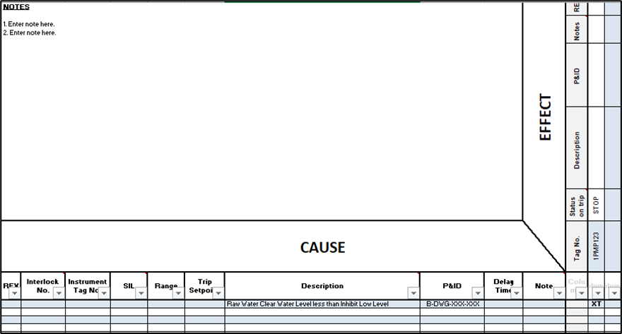
Figure 4-1: Example of C&E
Group control shutdown interlocks or crash stop interlocks should be documented in this section in narrative style, if applicable.
Refer to Section 7 Standard Functionality of I-SPE-STD-013 Control Systems Design and Construction Standard for additional information on interlocks.
- OHS, Equipment and Process Safety Features
Mitigations are designed to reduce the severity of effects caused by a process that has gone beyond the design envelope. These mitigations should be detailed here and include key safety features, either protecting the process, equipment or pertaining to Occupational Health and Safety (OHS). Examples include chlorine gas monitoring and alarming, bunding, and design to avoid mixing of incompatible chemicals.
E-stops are detailed here.
- Ancillaries Information
Detail any ancillaries related to the process group here. Reference interfaces with other process groups if required, e.g. Service Water System.
- Site/Area Process Hierarchy
Detail the process equipment hierarchy for the entire site/area (e.g. WTP or pipeline) below. Complete for required scope and place HOLD if not completing for entire site/area.
A diagram or table may be used, example table below. For more information see, I-SPE-STD-013 Control Systems Design and Construction Standard, and I-SPE-STD-009 Control Systems Architecture.
Table 5-5: Plant Equipment Hierarchy
Site | Area | Process Group | Process Unit | Device Tag
Example Only  North Pine Pump Station | Example Only  Raw Water | Example Only  Raw Water Pump Station | Example Only  Raw water pump set 1 | Example Only  1PMP001A
Example Only
1XV051
Example Only  Brisbane Network | Example Only  Pipeleg | Example Only  Green Hill  Reservoir Complex | Example Only  Green Hill  Reservoir 1 | Example Only  MIX001
 |  | Example Only  Water Quality Management Facility | Example Only  Chemical X Dosing | Example Only  PMP002

- Definitions & Abbreviations
Table 6-6: Definitions and Abbreviations
Term | Definitions
CCP | Critical Control Points
Contractor | An entity engaged by Seqwater to undertake work in accordance with an agreed contract with a defined scope of work.
Employees | Means persons employed directly by Seqwater in a permanent, temporary or casual capacity.
HACCP | Hazard Analysis and Critical Control Points
I/O | Input / Output
Leader | Means any Level 1, 2, 3 and 4 Leader with responsibility for managing a functional area of the business, including people management responsibilities within their functional area.
Manufacturer / Supplier / Vendor / Original Equipment Manufacturer (OEM) | The entity that manufacturers or supplies equipment to meet the specifications of the Contractor.
MAOP | Maximum Allowance Operating Pressure
MCC | Motor Control Centre
OHS | Occupational, Health and Safety
Owner / Principal / Seqwater | The entity that engages the Contractor to undertake the work and takes custody of the outcome. The Owner may delegate responsibilities to other entities to act on its behalf (e.g. a consultant).
P&ID | Piping and Instrumentation Diagram
PFD | Process Flow Diagram
PLC | Programmable Logic Controller
REX | Seqwater Electronic Document and Records Management System
SCADA | Supervisory Control and Data Acquisition
Seqwater Approval / Agreement / Acceptance | Written sign-off gained via the deviation process, as detailed in X-PRO-STD-008 Asset Standards Management and Application Procedure.
Seqwater Engineering Standard | Includes Standard Procedures and Standard Specifications and associated supporting documents such as Standard Drawings, Guidelines, Lists, Datasheets, Manuals, Registers, and Templates.
shall / must | Indicates a mandatory requirement.
should | Indicates a recommendation.
TSI | Technical Support and Improvement
UPS | Uninterruptable Power Supply
Worker(s) | Includes all permanent, temporary, and casual employees of Seqwater, and:  - vocational and work experience placements  - volunteers  - suppliers, contractors, and consultants temporarily engaged to do work for or on behalf of Seqwater.
XXX | Insert any other definitions or abbreviations used in this document here.
- References and Related Materials
The documents listed in Table 7-7 below, and the requirements therein, are relevant to this Document. In their latest editions, these documents form a part of this document. Note that this is not an exhaustive list of documents relevant to the works.
Seqwater undertakes regular updates of its Engineering Standards. Before utilising this document, the complete list of Seqwater Engineering Standards should be reviewed to ensure currency and applicability for the proposed works.
All references in the table below should be updated and linked to the latest revision before issue of this document.
Table 7-7: References and Related Material
Description | Location
D25/38190 Asset Location Standard | REX
PRO-01617 Engineering Standard X-PRO-STD-009 Engineering Design, Construction, Operation and Maintenance Procedure | REX
PRO-01872 Engineering Standard X-PRO-STD-002 Engineering Drawing Numbers Procedure | REX
PRO-01873 Engineering Standard X-PRO-STD-001 Asset Standards Documentation Classification and Naming Structure Procedure | REX
PRO-01874 Engineering Standard X-PRO-STD-004 Development and Review of Asset Standards Procedure | REX
PRO-02140 Engineering Standard X-PRO-STD-013 Engineering Technical Hazard Study Procedure | REX
PRO-02187 Engineering Standard X-PRO-STD-007 Drawing and Spatial Data Standards Procedure | REX
PRO-02190 X-PRO-STD-006 Equipment Numbering and Naming Convention Procedure | REX
PRO-02205 Engineering Standard X-PRO-STD-008 Asset Standards Management and Application Procedure | REX
PRO-02234 Management of Change (Technical) Procedure | REX
PRO-02329 Engineering Standard X-PRO-STD-019 Process Control Systems – Information Maintenance Procedure | REX
SPE-00320 WTP and Supply System – Process Validation Standard | REX
SPE-00349 Engineering Standard B-SPE-STD-005 Functional Description Documentation | REX
SPE-00356 Engineering Standard I-SPE-STD-005 High Priority Alarms & Interlocks Management | REX
SPE-00357 Engineering Standard I-SPE-STD-006 Alarm and Event Management | REX
SPE-00358 Engineering Standard I-SPE-STD-009 Control Systems Architecture | REX
SPE-00361 Engineering Standard I-SPE-STD-013 Control Systems Design and Construction | REX
SPE-00445 Engineering Standard B-SPE-STD-009 Liquid Chemical Storage and Dosing | REX
SPE-00481 Engineering Standard B-SPE-STD-011 Polymer, PAC, Pot Perm and Soda Ash Systems | REX
SPE-00496 Engineering Standard B-SPE-STD-012 Lime Storage, Mixing and Dosing System | REX
SPE-00519 Engineering Standard B-SPE-STD-013 Fluoride Storage, Mixing and Dosing Systems | REX
TEM-00222 Engineering Standard I-TMP-STD-005 Functional Description Part B Template | REX
TEM-00254 Engineering Standard I-TMP-STD-008 Master Alarms Template | REX
TEM-00327 Engineering Standard I-TMP-STD-013 Cause and Effect Matrix (C&E) Template | REX
[Insert others here. May include legislation, industry codes and standards, other mandated requirements, Seqwater policies, standards and procedures, etc.]
- Holds
The following HOLDs are noted throughout this document.
In the main document text, a hold is to be noted following the text or instead of the required text by noting [HOLD No.]. A search for HOLD No. can then be done to identify it.
Update Table 8-8 with holds as required. Once closed out, Holds can be removed in the next revision. Use Cross-references for Section Numbers so they update automatically if changes are made.
Table 8-8: HOLDs List
HOLD No. | Section Number | Description of HOLD | Status
1 |  |  | Open/Closed
2
3

Appendix A
- Filtration Process Group
Delete this section if a filtration process group is not included. Copy this section into the main document if a filtration process group is included.
The guidance notes in this section should be considered in addition to those provided in Section 4. Where there is a difference, this section shall prevail for filtration groups.
If the design incorporates a filtration process group this section should be removed as an appendix and moved up as a process group section.
If the design does not include a filtration process group this appendix shall be deleted.
- Process Group Description
Briefly describe the filtration process. Describe the design of the filter process and the media type. Describe the layout and interfaces with other process groups. Reference the relevant P&ID’s.
- Process Group Performance Requirements
Outline the performance requirements for the filtration system here. The following table can be used.
Table 9-9: Filtration Process Envelope
Parameter | Unit | Min | Target | Max
Filtration rate (Include assumptions, e.g. at sustainable filtered water flow of (X ML/day) with X filters On-Line (assuming X% efficiency) | m³/m²/hr
Filter run time (Include assumptions, e.g. X ML/day and settled water turbidity <X NTU) | hr
Air scour rate | m³/m²/hr
Low rate backwash | m³/m²/hr
High Rate backwash | m³/m²/hr
Minimum filter bed expansion during backwash | %
Volume of backwash water used per wash | m³
Waste backwash water discharged to the balancing tank per wash | m³
- Water Quality Envelope
Define the operating envelope and design envelope with regards to process variables such as flowrate, temperature, pressure and Water quality parameters relevant to the process group. A table can be used to present the data. Always include, where applicable, a reference to the site/area HACCP Plan for the latest values and refer to SPE-00320 WTP and Supply System – Process Validation Standard, for guidance.
Refer to PROXXXX Site/area HACCP Plan Wall Chart Procedure for the latest values.
- Process Constraints
Describe any constraints not already identified in the process and water quality envelopes. For example, backwashing constraints such as solids handling system limitations.
- Process Availability and Reliability Requirements
Describe the availability and reliability requirements. Outline any redundancy in the system. This should be complete with planned maintenance downtime and unplanned downtime.
- Equipment & Instrumentation Details
List the main mechanical equipment and their specifications that are required to describe normal operation. Pumps should show capacity as well as rating.
Table 9-10 : Equipment Details
Parameter/System Equipment Number | Description | Size | Units | Comment
List the main instrumentation and control valves, that are critical to the process and its control.
Table 9-11 : Instrumentation & Control Valve Details
Equipment Number | Description | Comment
- Filtration Process Operational Control Narrative
Describe here in narrative form how the filtration process group will be controlled in remote automatic operation.
This would include details on the group control of the process group including automatic management of online filters to keep within the operating envelope with regards to filtration rate.
Start permissives, process permissives and sequences to be described here in narrative form. Describe the different states and the procedures to move between states.
Tables are provided in this template to facilitate explanation of overarching process control and should be used in conjunction with a control narrative style. The below tables can be used as a summary in this section for listing adjustable control parameters and valve positions for different states.
Table 9-12 : Filtration Control Adjustable Parameters
Adjustable Parameters | Unit | Min | Max | Default | Operator Adjustable | Engineer Adjustable
Time delay after draindown before backwash commences | Sec |  |  |  | Yes/No | Yes/No
Time delay after draindown before air scour commences | Sec
Rate control valve position required to put filter into backwash queue (after 3600sec) | %
Maximum On-Line filter headloss required to put filter into backwash queue (after 600 sec) | m
Filtered water turbidity level required to put filter into backwash queue (after 1800 sec) | NTU
Target filter run time before filter put into backwash queue | hr
Air scour run time | sec
Combined air scour and low rate wash run time | sec
Low rate only backwash run time | sec
High rate backwash run time | sec
Extended Terminal Sub-fluidisation wash duration | sec
Maximum filter Off-Line time (without backwash when returning On-Line) if On-Line run timer is less than 30 minutes | min
Maximum filter Off-Line time (without backwash when returning On-Line) if On-Line run timer is more than 30 minutes | min
Maximum Filling Time (for automatic fill) | Sec
Maximum Filling Time (for manual Off-Line fill sequence) | Sec
Maximum Filter Draindown Time | Sec
Filter Standing Time Period (after Backwash Sequence before executing On-Line Procedure) | Sec
Allowable waiting time for Draindown Sequence to commence after a Backwash Procedure has been initiated | Sec
Filter outlet Rate Control Valve Fast Opening Rate A | %/min
Filter outlet Rate Control Valve Fast Opening Setting B | %
Filter outlet Rate Control Valve Minimum Opening Setting C | %
Filter outlet Rate Control Valve Slow Start Opening Rate D | %/min
Filter outlet Rate Control Valve Slow Start Opening Setting E | %
High Level Reservoir minimum water level setting for gravity backwash
- Control Principals
Explain the main control principals in the filtration process group here.
- Flow Rate Control
Explain any flow rate control here.
- Level Control
Explain any level control here.
- Valve Control
Explain any valve control here.

- States
Explain how the states transition between each other or use the table below as a guideline. The headings and sections below are to be used as a guide only and can be changed as required. Graphics should be used to support the description of states.
Table 9-13 : Filter states & corresponding valve positions
Filter Status | Valve Position (add or remove valves as needed)
Filter Status | Filter Inlet | DAF Vessel Inlet & Outlet | Filter Outlet Control | Washout | Air-Scour Inlet | Air Relief | Air-Scour Soft Start | Backwash Inlet | Backwash Control | Filter Outlet Isolation | Filter- Waste Isolation
Valve tag no.
In Service
Unavailable
Available
Drain down
Air-Scour
Backwash
Refill
Filter-To-Waste

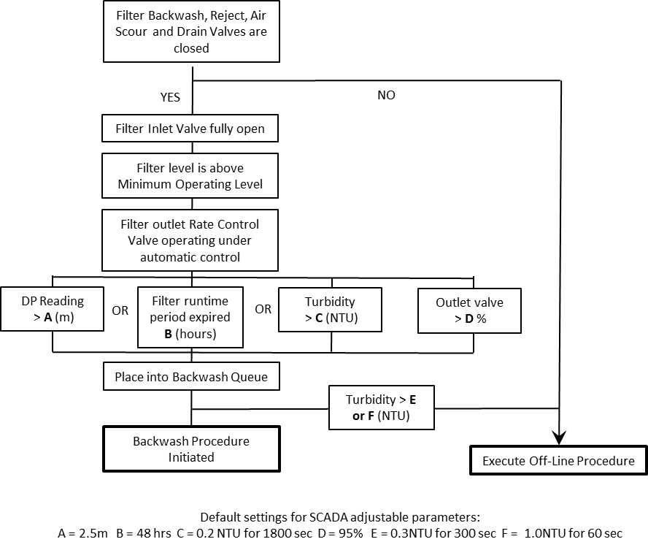
Figure 9-2: Example of Online State Transition
- Procedures
Explain the procedures for moving between states of the filtration process group here.
- Offline Procedure
Outline the procedure to move into the Offline state. Add graphic(s) to support the procedure.
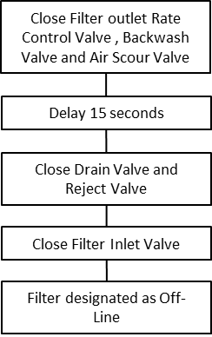
Figure 9-3: Example of Offline Sequence Procedure
- Online Procedure
Outline the procedure to move into the Online state. Add graphic(s) to support the procedure.

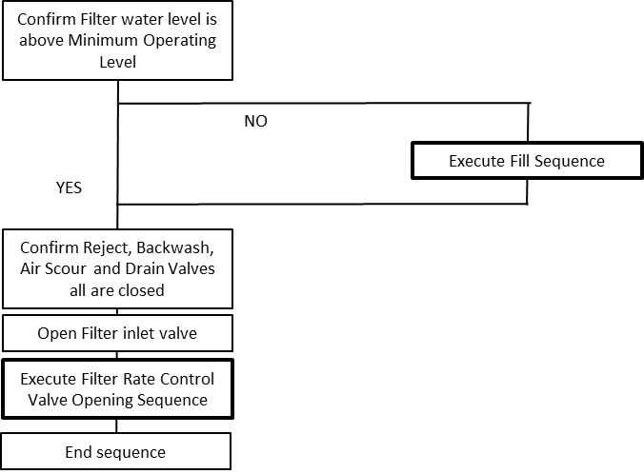
Figure 9-4: Example of Online Sequence Procedure

- Backwash Control Narrative
Explain the process control of filter backwashing in this section. Structure of the headings and sections below are to be used as a guide only and can be changed as required. Graphics should be used to support the description of states and procedures.
- Filter Drain Down
Describe the filter drain down control sequence(s).
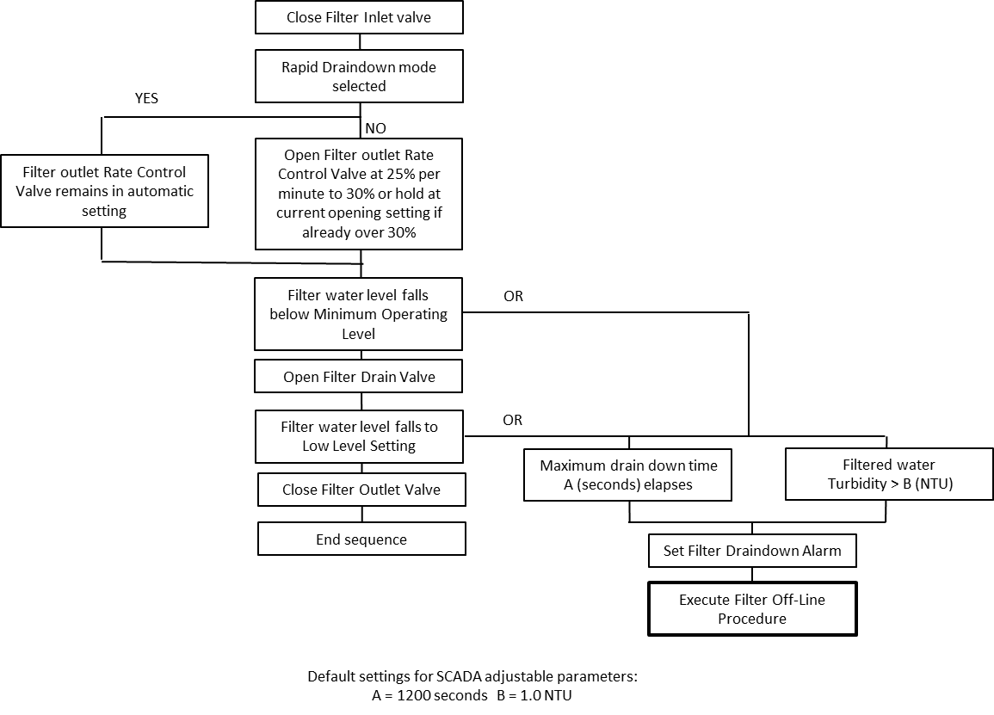
Figure 9-5: Example of Drain Down Sequence for Online Filter Procedure

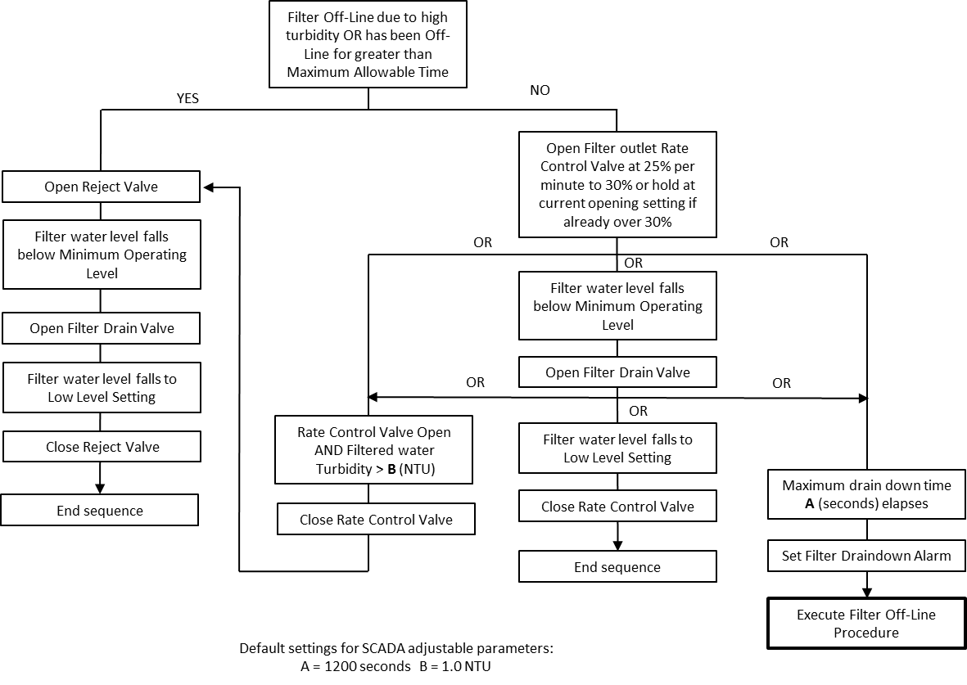
Figure 9-6: Example of Drain Down Sequence for Online Filter Procedure

- Air Scouring
Describe the filter flow velocity backwash and air scouring control.
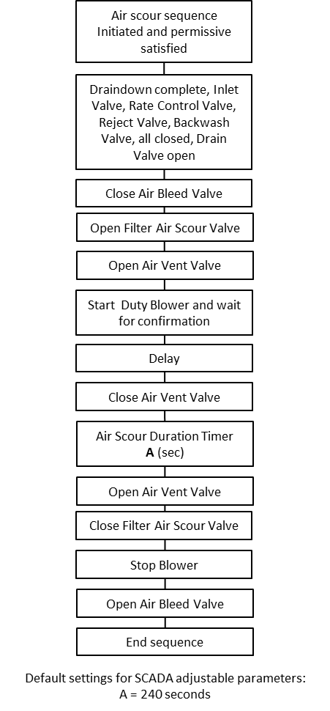
Figure 9-7: Example of Air Scouring Sequence Procedure
- Filter High Velocity Backwash
Describe the filter high flow velocity backwash control.
- Filter Ripening
Describe the filter ripening period control.
- Filter Queuing
Describe how the filter queuing is controlled.
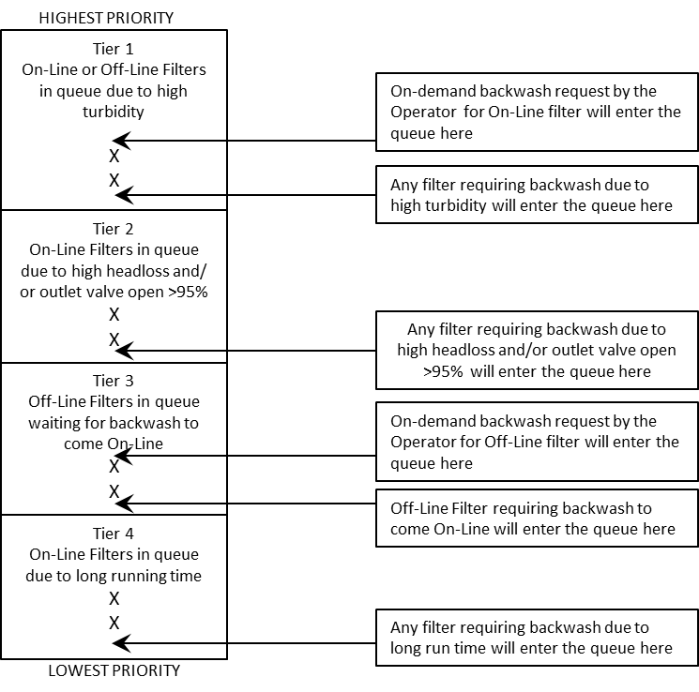
Figure 9-8: Example of Filter Queuing

- Backwash Sequence
Describe the Backwash Sequence. Add graphic to support procedure.
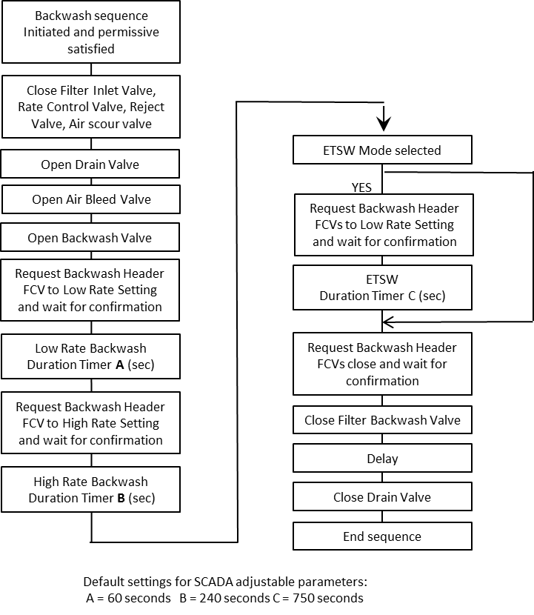
Figure 9-9: Example Backwash Sequence Procedure
- Abnormal Operation
Define the abnormal conditions here and describe briefly how the process group will operate under these abnormal conditions. Abnormal conditions are those where the process group is outside of the operating envelope but within the design envelope. An example of abnormal operation could be high raw water turbidity during an adverse weather event requiring reduced flowrates through a process group.
This section describes what will happen in the event of abnormal operation and how the system is designed to prevent abnormal operation. It should focus on the safety of the operator, prevention of damage to equipment, prevention of environmental incidents and / or Seqwater’s social license to operate.
- Process Critical Alarms
Process critical alarms, designed as mitigations in the process design, shall be documented here in Part A and captured in a Master Alarm Register for the site/area (I-TMP-STD-008 Master Alarms Template (TEM-00254)). The Master Alarm Register and Functional Description Part B will contain all alarms for the site/area. This section is just for alarms required in the process design to prompt operator action to keep the process group within its operating envelope.
CCP alarms and setpoints are documented in the site HACCP Plan and HACCP Wall Chart Procedure, which can be referenced here. Contact engineering@seqwater.com.au for more information.
Add any alarm suppression requirements here, for example, suppress alarm X on plant start up until condition Y is met.
See I-SPE-STD-006 Monitoring and Control System Alarm and Event Management and I-SPE-STD-005 High Priority Alarms & Interlocks Management, for more detail design and management.
- Faults & Interlocks
Describe here in narrative format the interlocks at device level and group control shutdown interlocks (if applicable) which, are used as safeguards and mitigations to maintain safe process operation, within the design envelope.
This section should predominantly include trip interlocks. Hardware interlocks are only shown when they are used as a critical safeguard or mitigation to maintain operation within the design envelope. The complete list of hardware interlocks will be in Functional Description Part B.
Process permissives and start permissives are not to be included here and are covered in the Process Operational Control Narrative.
Interlocks should be considered from the perspective of the design envelope. How do the interlocks function to prevent the process from moving beyond the design envelope.
I-TMP-STD-013 Cause and Effect Matrix Template (TEM-00327) shall be used for hardware safety trips and trip interlocks. Define each interlock in terms of its individual cause and effect. For example, if the raw water tank level is less than inhibit low level, the pump will be prevented from starting or will trip and stop if already running.
The cause and effect shall look like this:

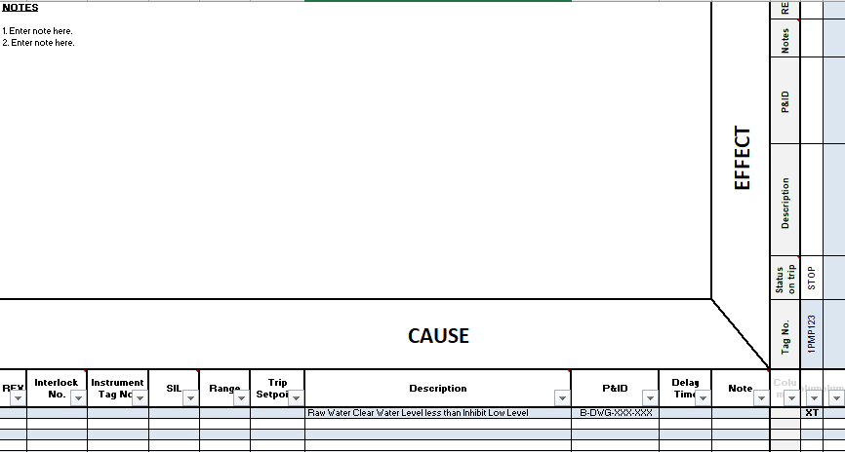
Figure 9-10: Example of C&E
Group control shutdown interlocks or crash stop interlocks should be documented in this section in narrative style, if applicable. Refer to Section 7 Standard Functionality of I-SPE-STD-013 Control Systems Design and Construction Standard for additional information on interlocks.
- OHS, Equipment and Process Safety Features
Mitigations are designed to reduce the severity of effects caused by a process that has gone beyond the design envelope. These mitigations should be detailed here and include key safety features, either protecting the process, equipment or pertaining to Occupational Health and Safety (OHS). Examples include chlorine gas monitoring and alarming, bunding and design to avoid mixing of incompatible chemicals.
E-stops are to be detailed here.
- Ancillaries Information
Detail any ancillaries related to the process group here. Reference interfaces with other process groups if required.

